## Chapter 1.4.3 Debugging, Monitoring, and Tuning Performance

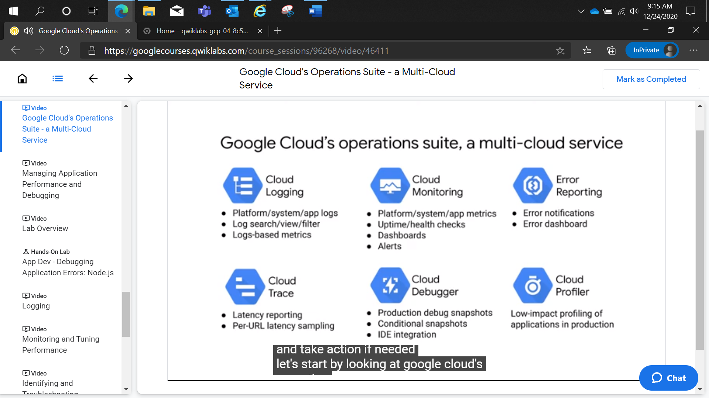

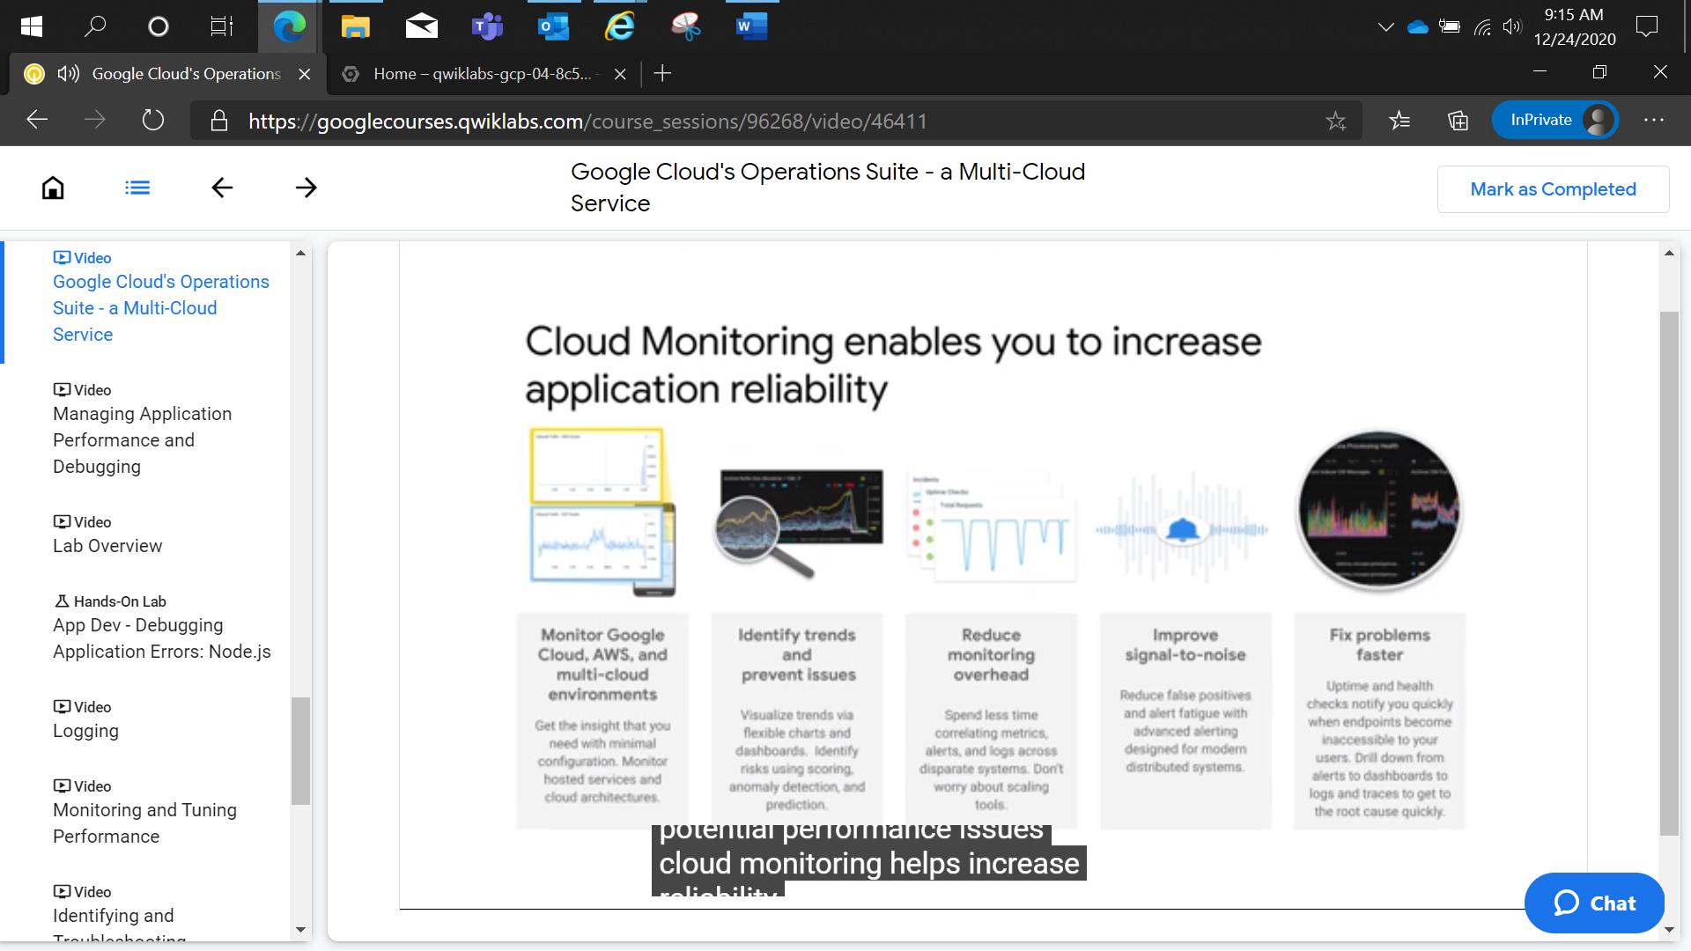

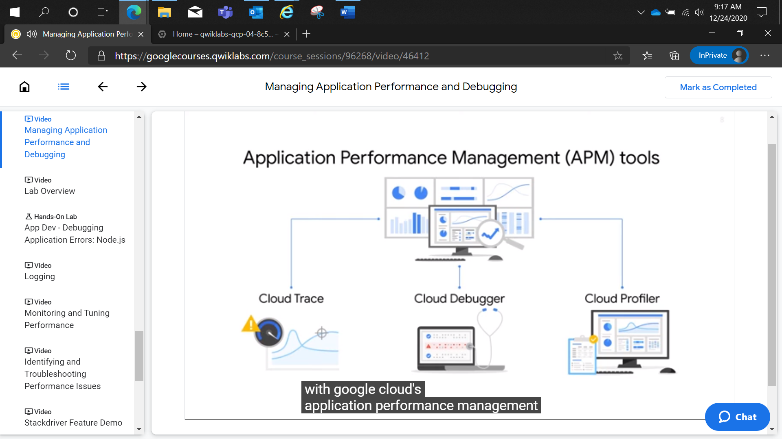

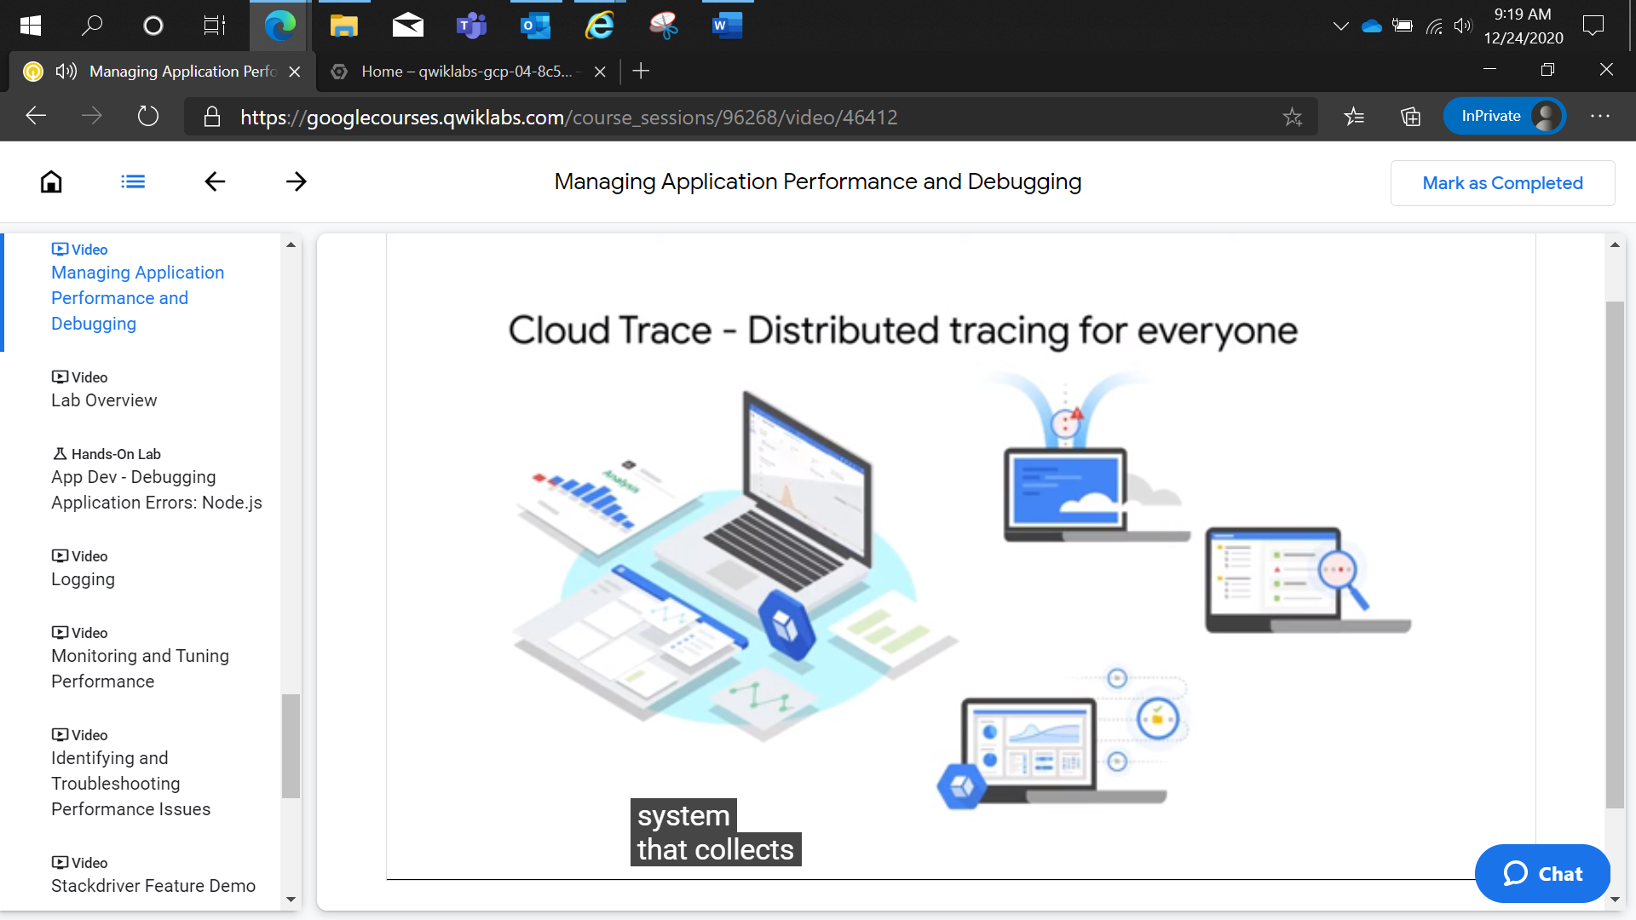

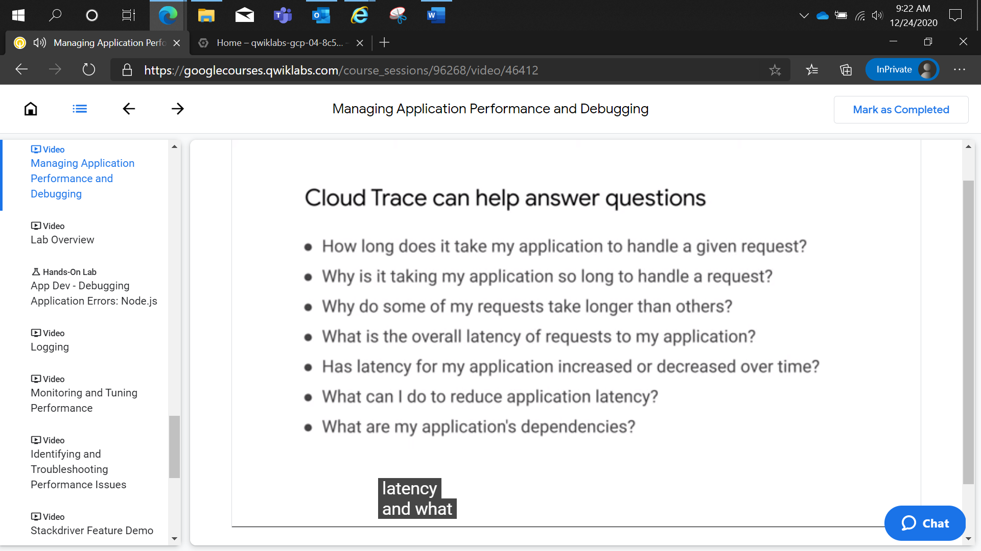

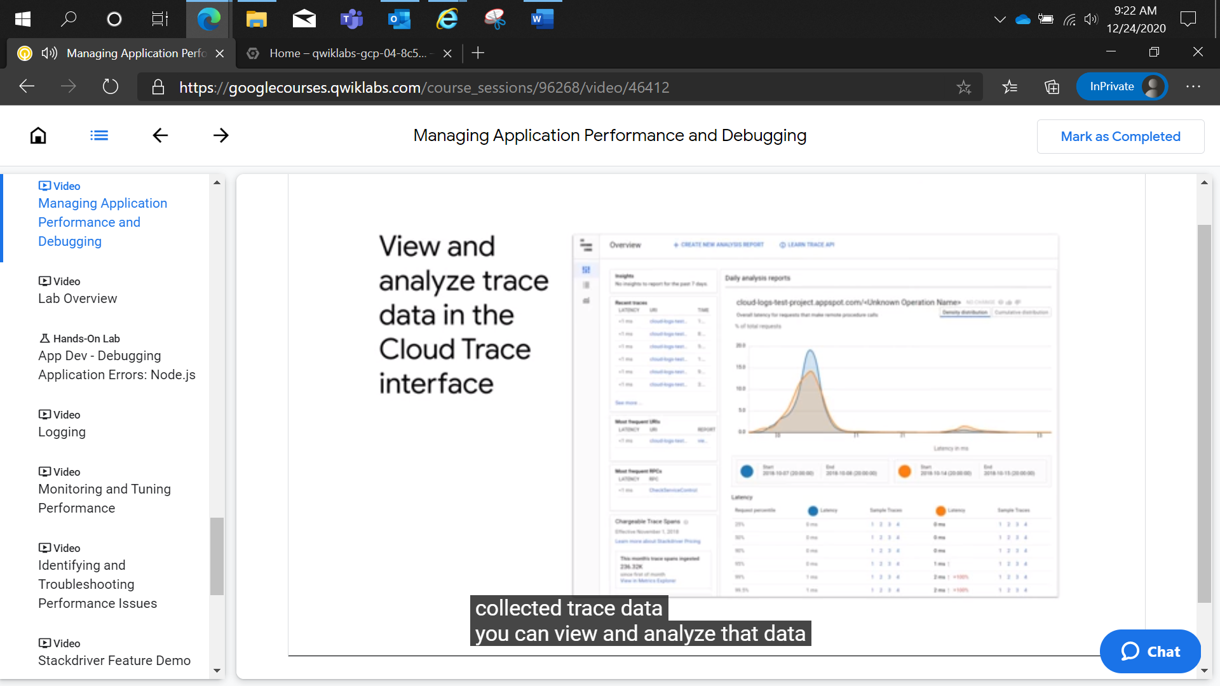

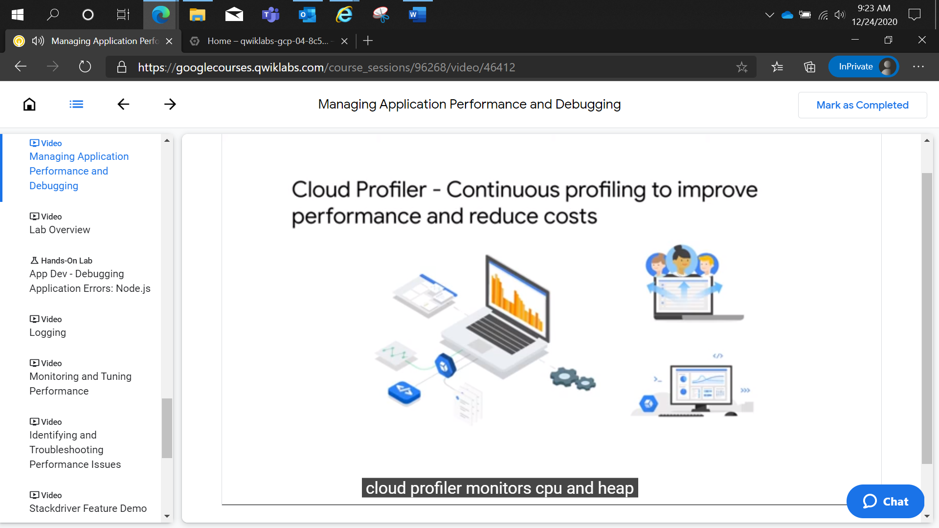

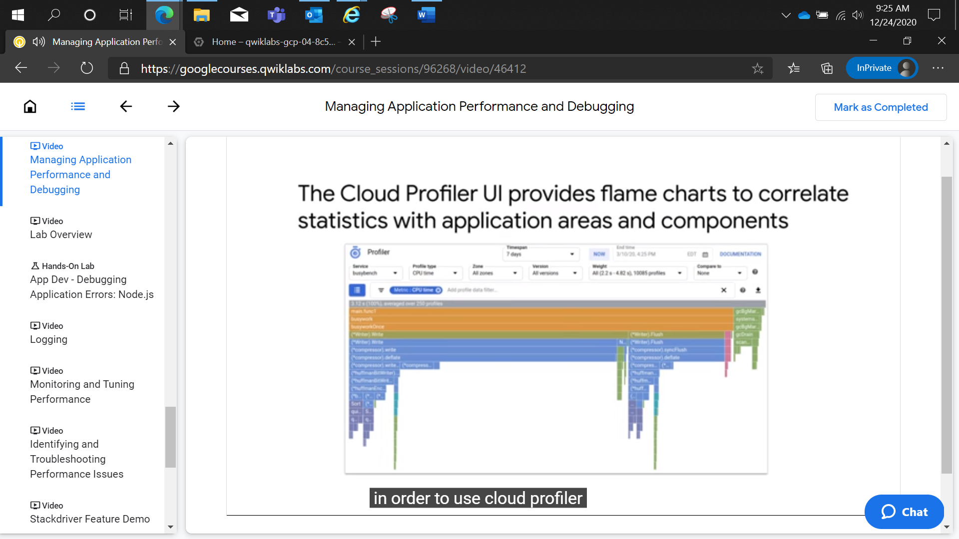

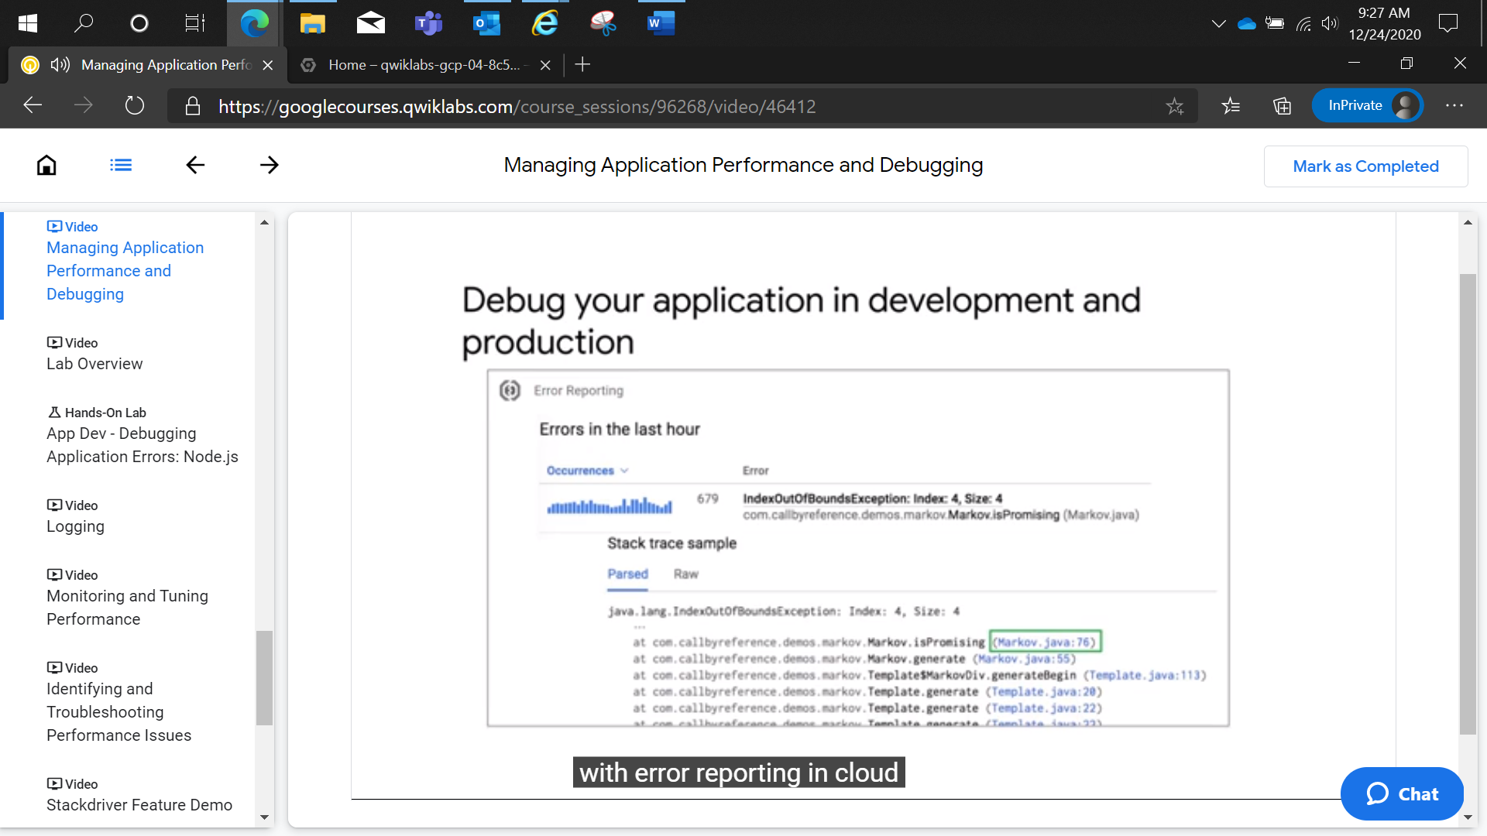

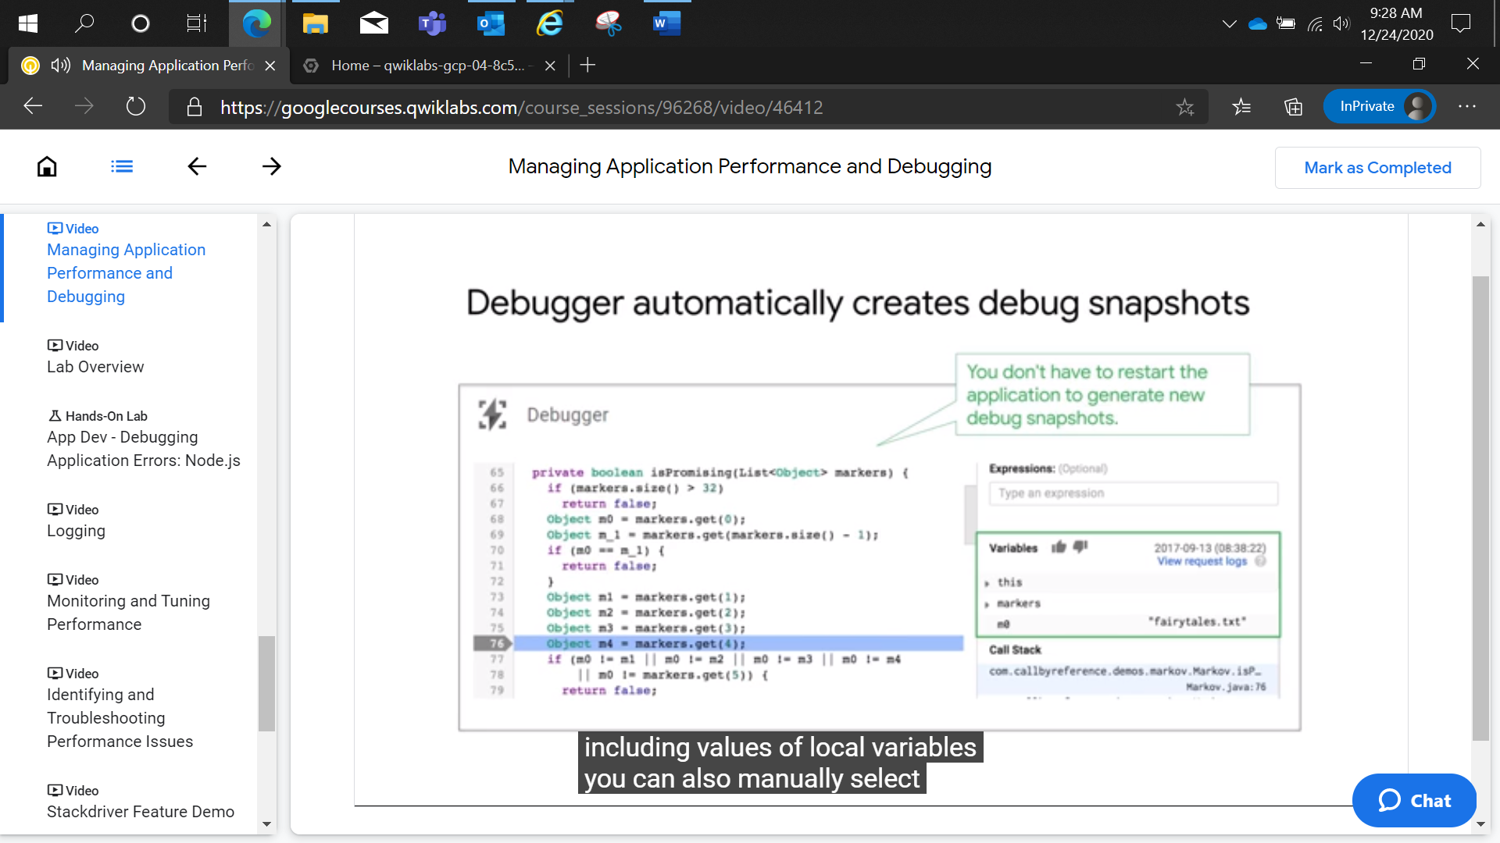

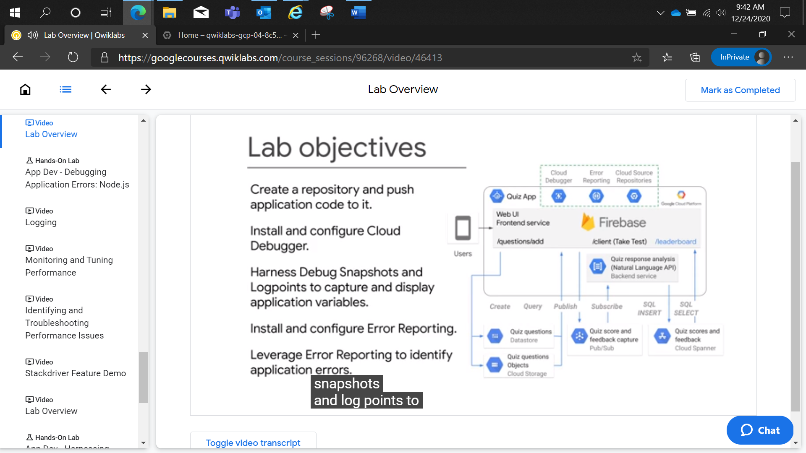

# **App Dev - Debugging Application Errors: Node.js**

2 hoursFree

Rate Lab

## Overview

In this lab, you leverage Cloud Debugger and Error Reporting to diagnose and fix errors in the running application.

## Objectives

In this lab, you learn how to perform the following tasks:

* Create a Cloud Source Repository and push application code to it.
* Install and configure Cloud Debugger.
* Use debug snapshots and logpoints to capture and display application variables.
* Install and configure Cloud Error Reporting.
* Leverage Cloud Error Reporting to identify application errors.

## Setup and requirements

For each lab, you get a new GCP project and set of resources for a fixed time at no cost.

1. Make sure you signed into Qwiklabs using an **incognito window**.
2. Note the lab's access time (for example, 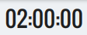 and make sure you can finish in that time block.

There is no pause feature. You can restart if needed, but you have to start at the beginning.

1. When ready, click 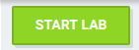.
2. Note your lab credentials. You will use them to sign in to Cloud Platform Console. 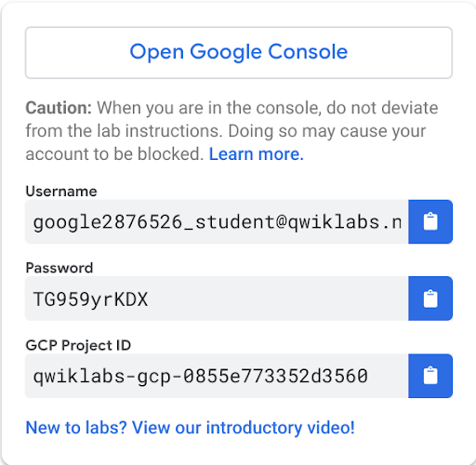
3. Click **Open Google Console**.
4. Click **Use another account** and copy/paste credentials for **this** lab into the prompts.

If you use other credentials, you'll get errors or **incur charges**.

1. Accept the terms and skip the recovery resource page.

Do not click **End Lab** unless you are finished with the lab or want to restart it. This clears your work and removes the project.

### **Activate Google Cloud Shell**

Google Cloud Shell is a virtual machine that is loaded with development tools. It offers a persistent 5GB home directory and runs on the Google Cloud. Google Cloud Shell provides command-line access to your GCP resources.

1. In GCP console, on the top right toolbar, click the Open Cloud Shell button.

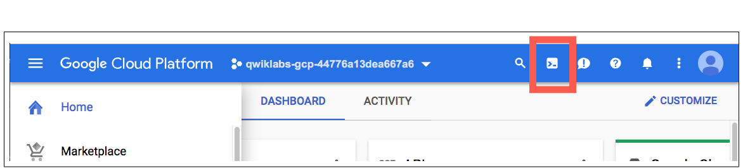

1. Click **Continue**. 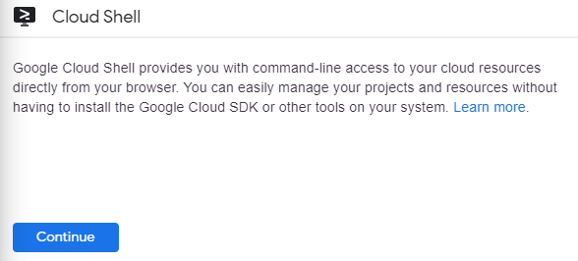

It takes a few moments to provision and connect to the environment. When you are connected, you are already authenticated, and the project is set to your PROJECT_ID. For example:

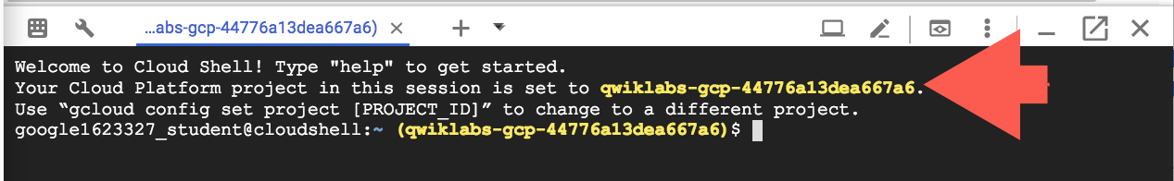

**gcloud** is the command-line tool for Google Cloud Platform. It comes pre-installed on Cloud Shell and supports tab-completion.

You can list the active account name with this command:

gcloud auth list

content_copy

Output:

Credentialed accounts:

- <myaccount>@<mydomain>.com (active)content_copy

Example output:

Credentialed accounts:

- google1623327_student@qwiklabs.netcontent_copy

You can list the project ID with this command:

gcloud config list project

content_copy

Output:

[core]

project = <project_ID>content_copy

Example output:

[core]

project = qwiklabs-gcp-44776a13dea667a6content_copy

Full documentation of **gcloud** is available on [Google Cloud gcloud Overview](https://cloud.google.com/sdk/gcloud).

## Preparing the Case Study Application

In this section, you access Cloud Shell, clone the git repository containing the quiz application, configure environment variables, and run the application.

### **Clone source code in Cloud Shell**

1. To clone the repository for the class, execute the following command:

git clone https://github.com/GoogleCloudPlatform/training-data-analystcontent_copy

1. Create a softlink as a shortcut in your working directory

ln -s ~/training-data-analyst/courses/developingapps/v1.2/nodejs/stackdriver-debug-errorreporting ~/stackdriver-debug-errorreportingcontent_copy

### **Configure and run the case study application**

1. Change to the directory that contains the sample files for this lab.:

cd ~/stackdriver-debug-errorreporting/startcontent_copy

1. To configure the Quiz application, execute the following command:

. prepare_incomplete_environment.shcontent_copy

This script file

* Creates an App Engine application.
* Exports environment variables GCLOUD_PROJECT and GCLOUD_BUCKET.
* Runs npm install.
* Creates entities in Google Cloud Datastore.
* Creates a Cloud Spanner instance.
* Does NOT create a Google Cloud Pub/Sub topic.
* Does NOT create a Cloud Spanner database.
* Prints out the Google Cloud Platform Project ID.

## Creating a Cloud Source Repository

In this section, you create a Cloud Source Repository and push the current lab's Quiz application code to it.

### **Create a Cloud Source Repository**

1. In the **Cloud Platform Console**, on the **Navigation menu**, click **Source Repositories**.
2. Click **Add repository** in the top right corner.
3. Select **Create new repository**, and then click **Continue**.
4. Name the repository default, and then for **Project**, select the project named with your GCP Project ID from the dropdown menu.
5. Click **Create**.

The **Add code to your repository** dialog opens.

### **Clone the Repository**

1. Return to the **Cloud Shell** window.
2. To change the working directory back to the home folder, execute the following command:

cd ~content_copy

1. To clone the default Cloud Source Repository, execute the following command:

gcloud source repos clone defaultcontent_copy

Ignore the warning about cloning an empty repository.

1. To copy the quiz application files from the lab folder into the repository, execute the following command:

cp -r ~/stackdriver-debug-errorreporting/start/quiz-app/* ~/defaultcontent_copy

The idea here is that you just want to simulate working on the Quiz application in the project's Cloud Source Repository.

1. Change the working directory to the default directory.

cd ~/defaultcontent_copy

1. Create a .gitignore file in the default folder to prevent the node_modules folder from being included in later git commands.

echo node_modules > .gitignorecontent_copy

1. Enter the git command to add files to be committed.

git add .content_copy

1. Enter the commands to configure git with your email and name.

git config --global user.email "student@example.com"

git config --global user.name "A Student"content_copy

1. Enter the git command to commit the changes with the message "Quiz application initial check-in".

git commit -m "Quiz application initial check-in"content_copy

1. Enter the git command to push the changes into the default repository.

git pushcontent_copy

1. Return to the **Source Repository** window and refresh the browser tab.

The Cloud Source Repositories window opens and shows the quiz application source code that you copied into the repository.

## Using Cloud Debugger

In this section, you write the code to create and start the Cloud Debugger in the quiz application and then set debug snapshots and logpoints in the Cloud Platform Console.

**Important**: Update code within the sections marked as follows:

// TODO

// END TODO

To maximize your learning, review the code, inline comments, and related API documentation.

### **Write code to set up Cloud Debugger**

1. In **Cloud Shell**, to install the Node.js agent for Cloud Debugger, execute the following command:

cd ~/default

npm install --save @google-cloud/debug-agentcontent_copy

1. Click **Open Editor**.

If an error indicates that the code editor could not be loaded because third-party cookies are disabled, click **Open in New Window** and switch to the new tab.

1. In the default/app.js file, import the '@google-cloud/debug-agent' module and then start it. For more information see: <https://cloud.google.com/debugger/docs/setup/nodejs>.

#### default/app.js

*// TODO: Add the following statement to import and start*

*// Cloud debug-agent*

*// The start(...) method takes an 'options' object that you*

*// can use to configure the Cloud Debugger agent.*

*// You will need to pass through an object with an*

*// allowExpressions Boolean property set to true.*

require('@google-cloud/debug-agent').start({ allowExpressions: true });

*// END TODO*content_copy

1. Save the file.

### **Update the Cloud Source Repository and produce a source context**

1. Return to the **Cloud Shell** window.

If the Cloud Shell is not visible, click **Open Terminal**.

1. To add, commit, and push the changes to the default Cloud Source Repository, execute the following commands:

cd ~/default

git add .

git commit -m "Added Cloud Debug Agent"

git pushcontent_copy

1. To produce the source context file, execute the following command:

gcloud debug source gen-repo-info-file --output-directory .content_copy

This command creates the source-context.json file. This file allows Cloud Debugger to display the correct source code in the Cloud Platform Console Debug window.

### **Debug the web application with a Snapshot**

1. To install the quiz application dependencies and start the application, execute the following command:

npm install

npm startcontent_copy

1. When you see App listening on port 8080, click **Web preview** > **Preview on port 8080** to preview the quiz application.
2. Return to the **Cloud Platform Console**.
3. On the **Navigation menu**, click **Debugger**.

You should see that the source code for the application is displayed on the left-hand side of the Cloud Debug window.

1. Use the source code navigator to select the **web-app/questions.js** file.
2. Find the POST handler where questions are added (router.post('/add..)), and click the line number on the left-hand side of the blank statement just after let data = req.body.

This inserts a snapshot into the source code.

You should see in the right-hand panel that Cloud Debug is waiting for the snapshot to be hit.

1. Return to the Quiz application and click **Create Question**.
2. Fill in the form using the following values, and then click **Save**.

|  |  |
| --- | --- |
| **Form Field** | **Value** |
| Author | Your Name |
| Quiz | Google Cloud Platform |
| Title | Which are Google Cloud products? |
| Answer 1 | Debug |
| Answer 2 | Error Reporting |
| Answer 3 | Logging |
| Answer 4 | **All of the above** (Select answer 4 as correct!) |

1. Return to the **Cloud Debug** window in the **Cloud Platform Console**.

Look at the right-hand panel.

You should see that the snapshot has populated the Variables and Call Stack for the request.

1. Expand the data variable.

You should see the data that you entered into the form.

### **Debug the web application with a logpoint**

1. Still in questions.js, click on the **Logpoint** tab of the right panel in the **Debug** window.
2. Click on the same source code line that you used to insert the snapshot.

This inserts a logpoint into the source code.

An interactive editor opens where you can enter a statement that will be emitted to the application's logging output.

1. In the logpoint interactive editor, write the following logging statement and click **Add**.

if (true) logpoint("Quiz = {data.quiz}")

content_copy

This logging statement prints out the value of the quiz form field.

1. Return to the Quiz application and, click **Create Question**.
2. Fill in the form using the following values, and then click **Save**.

|  |  |
| --- | --- |
| **Form Field** | **Value** |
| Author | Your Name |
| Quiz | Google Cloud Platform |
| Title | Which Google Cloud product includes snapshots and logpoints? |
| Answer 1 | **Debugger** (Select answer 1 as correct!) |
| Answer 2 | Error Reporting |
| Answer 3 | Logging |
| Answer 4 | All of the above |

1. Return to the **Cloud Shell** window.

You should see that the logpoint output is displayed in the form:

**LOGPOINT: Quiz = 'gcp'**

## Using Cloud Error Reporting

In this section, you write the code to integrate Cloud Error Reporting in the quiz application and observe errors from the web application and from Cloud Functions.

### **Write code to set up Cloud Error Reporting**

1. In **Cloud Shell**, to stop the web application, press **Ctrl+C**.
2. To install the Node.js library for Cloud Error Reporting, execute the following command:

cd ~/default

npm install --save @google-cloud/error-reportingcontent_copy

1. In the **Cloud Shell** code editor, navigate to **default/app.js**.
2. In the app.js file, load the '@google-cloud/error-reporting module.
3. Create the Cloud Error Reporting client.

#### default/app.js

*// TODO: Load the error-reporting module*

const {ErrorReporting} = require(

'@google-cloud/error-reporting');

*// END TODO*

const path = require('path');

const express = require('express');

const config = require('./config');

const app = express();

*// TODO: Create the errorReporting client object*

const errorReporting = new ErrorReporting();

*// END TODO*content_copy

1. Configure the application to [use Cloud Error Reporting with Express](https://cloud.google.com/error-reporting/docs/setup/nodejs).

#### default/app.js

*// Use Cloud Error Reporting*

*// middleware for Express*

app.use(errorReporting.express);

*// END TODO*content_copy

1. Save the file.

### **Update the Cloud Source Repository and produce a new source context**

1. Return to **Cloud Shell** window, and then stop the web application by pressing Ctrl+C.
2. To add, commit, and push the changes to the default Cloud Source Repository, execute the following commands:

cd ~/default

git add .

git commit -m "Added Cloud Error Reporting"

git pushcontent_copy

1. To produce source context file, execute the following command:

gcloud debug source gen-repo-info-file --output-directory .content_copy

This command updates the source-context.json file so that the source displayed by Error Reporting matches the executing application.

### **View web application errors using Error Reporting**

1. By default, Cloud Error Reporting is only active when the application is in production. Export an environment variable, NODE_ENV, with the value set to production.

export NODE_ENV=productioncontent_copy

1. To start the application, execute the following command:

npm startcontent_copy

1. Preview the web application.
2. Return to the **Cloud Platform Console**.
3. On the **Navigation menu**, click **Error Reporting**.

You should see that Error Reporting hasn't displayed any errors yet.

Ignore the "Set up Error Reporting" button.

1. Return to the quiz application, and click **Take Test**.
2. Click **Places**.
3. Complete the quiz, enter a rating and some feedback, and click **Send Feedback**.

No 'Feedback Sent' response message is displayed.

1. Return to the **Cloud Platform Console**.
2. On the **Navigtion menu** menu, click **Error Reporting**.
3. Click **Auto Reload**.

After a few seconds, an error message is displayed.

In this case, the error was due to infrastructure misconfiguration. The Pub/Sub feedback topic was not created.

### **View Cloud Function errors using Error Reporting**

1. Return to **Cloud Shell** and stop the web application by pressing **Ctrl+C**.
2. To create the missing Pub/Sub topic, execute the following command:

gcloud beta pubsub topics create feedbackcontent_copy

1. To create the Cloud Function that subscribes to the feedback topic and inserts a record into Cloud Spanner, execute the following commands:

cd ~/stackdriver-debug-errorreporting/start/

gcloud functions deploy process-feedback --runtime nodejs8 \

--trigger-topic feedback --source ./function \

--stage-bucket $GCLOUD_BUCKET --entry-point subscribe

cd ~/defaultcontent_copy

It takes a few minutes to provision the Cloud Function.

1. To start the web application, execute the following command:

npm startcontent_copy

1. Preview the web application.
2. Return to the quiz application, and click **Take Test**.
3. Click **Places**.
4. Complete the quiz, enter a rating and some feedback, and click **Send Feedback**.

This time, Cloud Shell displays the 'Feedback Sent' response message.

1. Return to the **Cloud Platform Console**.
2. On the **Navigation menu**, click **Error Reporting**.

After a few seconds, a new error message is displayed.

In this case, the error was also due to infrastructure misconfiguration. The Cloud Spanner database and Feedback table were not created.

1. Click on the **{Error: Resource not found...}** link.

This error was reported from the process-feedback Cloud Function.

You will see the Error Reporting details for all the parts of the application.

1. In the **Recent samples** section of the window, click on the **View logs** link for the Cloud Functions error.

Cloud Functions errors automatically integrate with Cloud Logging.

You should see an Error log item.

1. To create the database and Feedback table, return to **Cloud Shell**, stop the web application, and then run the following command:

gcloud spanner databases create quiz-database --instance quiz-instance --ddl "CREATE TABLE Feedback ( feedbackId STRING(100) NOT NULL, email STRING(100), quiz STRING(20), feedback STRING(MAX), rating INT64, score FLOAT64, timestamp INT64 ) PRIMARY KEY (feedbackId);"content_copy

## Bonus: Finding a Logic Error in the Quiz Application

In this section, you find an error in the Quiz application and use Cloud Debugger to identify the cause.

### **Reproduce the quiz application error**

1. Start the web application.
2. Navigate to the Quiz application homepage and click **Take Test**.
3. Click **Places**.
4. Answer the question correctly.
5. Click **GCP**, and then click **Places** again.
6. Answer the question incorrectly.
7. What score do you see?

You should see that the score is wrong.

The author included a logic error (on purpose of course!) somewhere in the application.

Your job is to track it down.

**Review**

When using Cloud Debugger, which gcloud command do you use to specify the source code that is to be synchronized?

1. gcloud compute instances create...
2. gcloud app create...
3. gcloud service-management create....
4. gcloud debug source gen-repo-info-file...

What statements are true about Cloud Debugger snapshots?

1. Snapshots capture all the local variables.
2. Snapshots output data to logging output.
3. Snapshots can include filters.
4. Snapshots halt code execution on the running application.

When you use Cloud Error Reporting, how are errors integrated with Express?

1. Add an error handler to Express, and invoke the Error Reporting client object's reportError(...) method.
2. Register the Error Reporting client's express handler with Express.

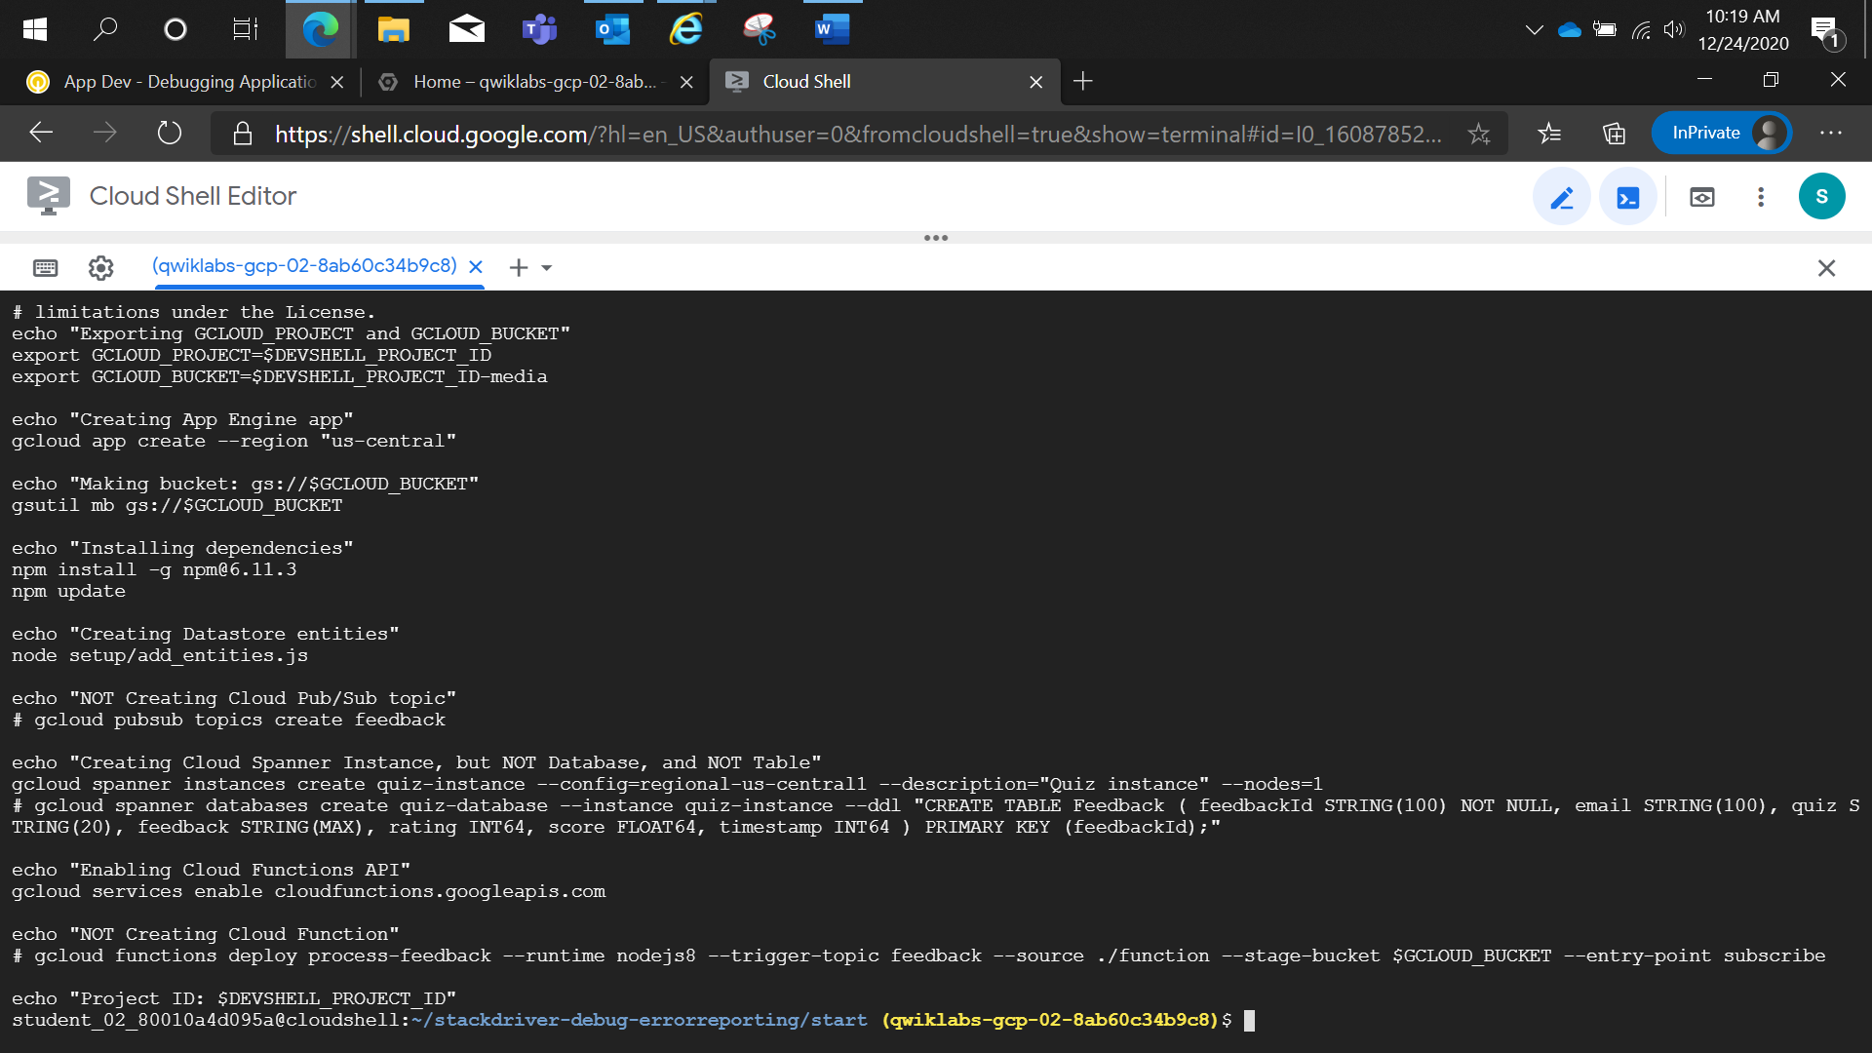

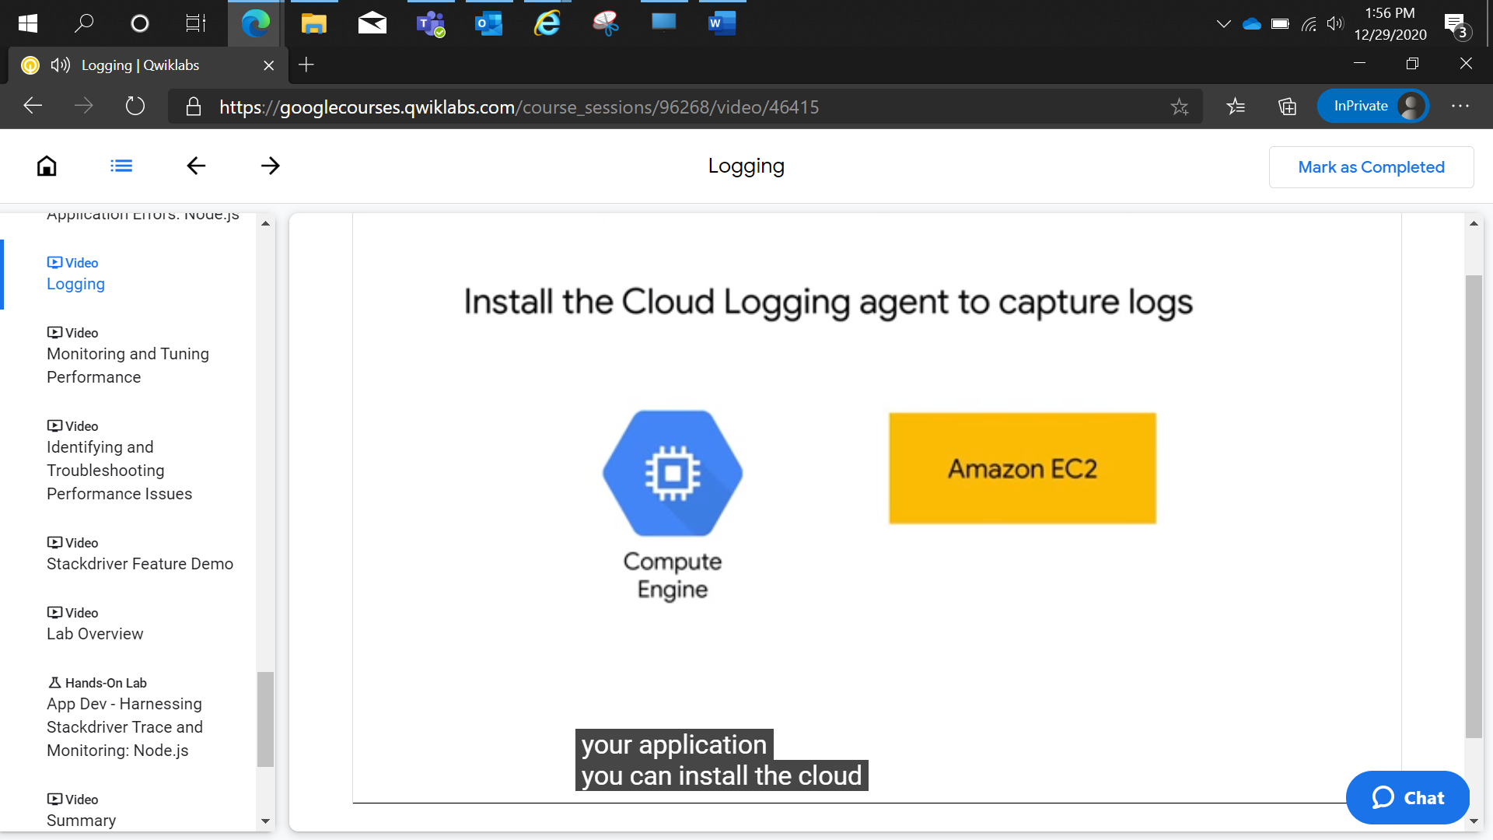

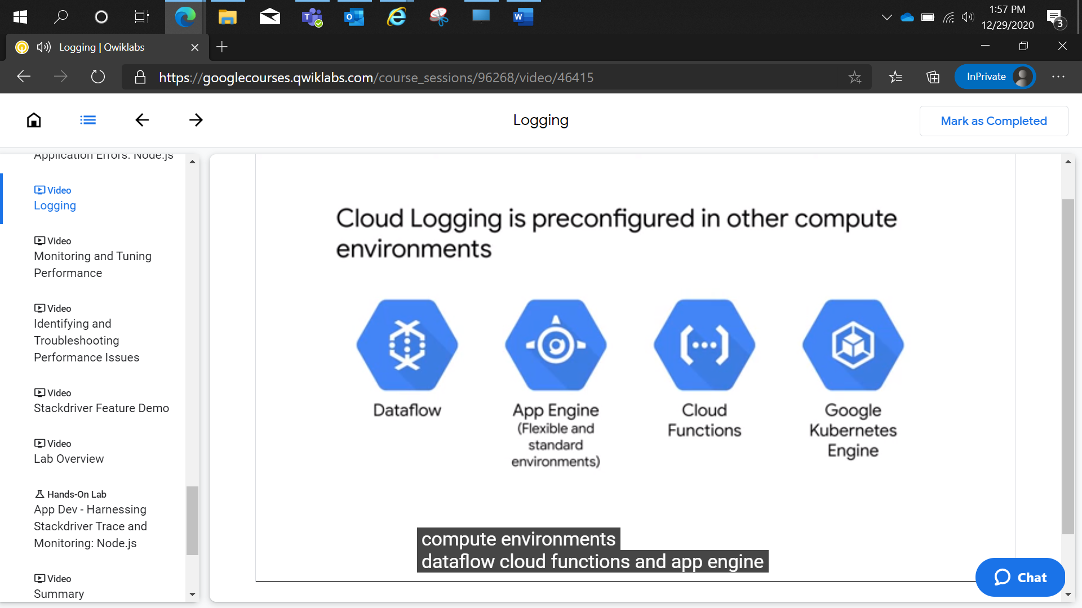

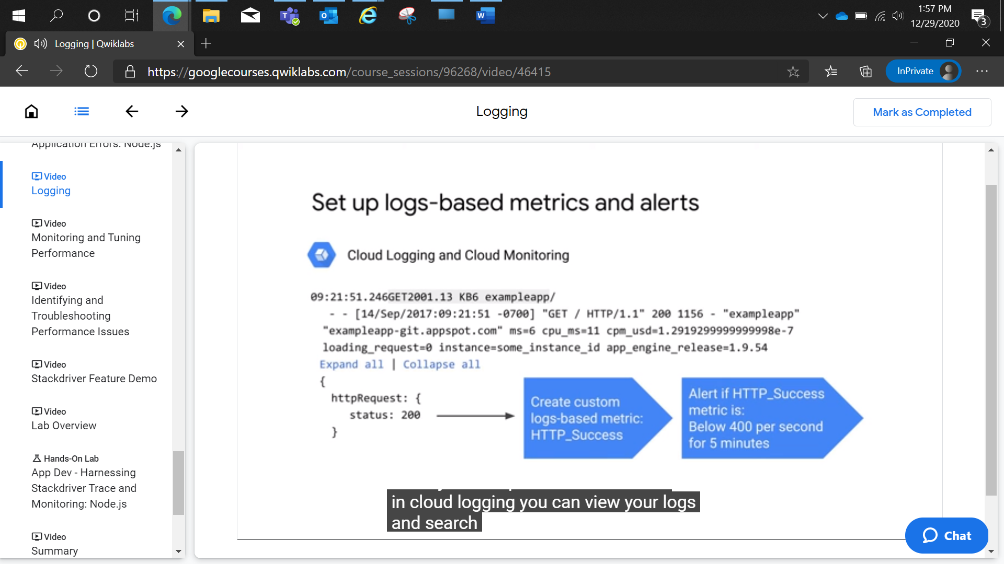

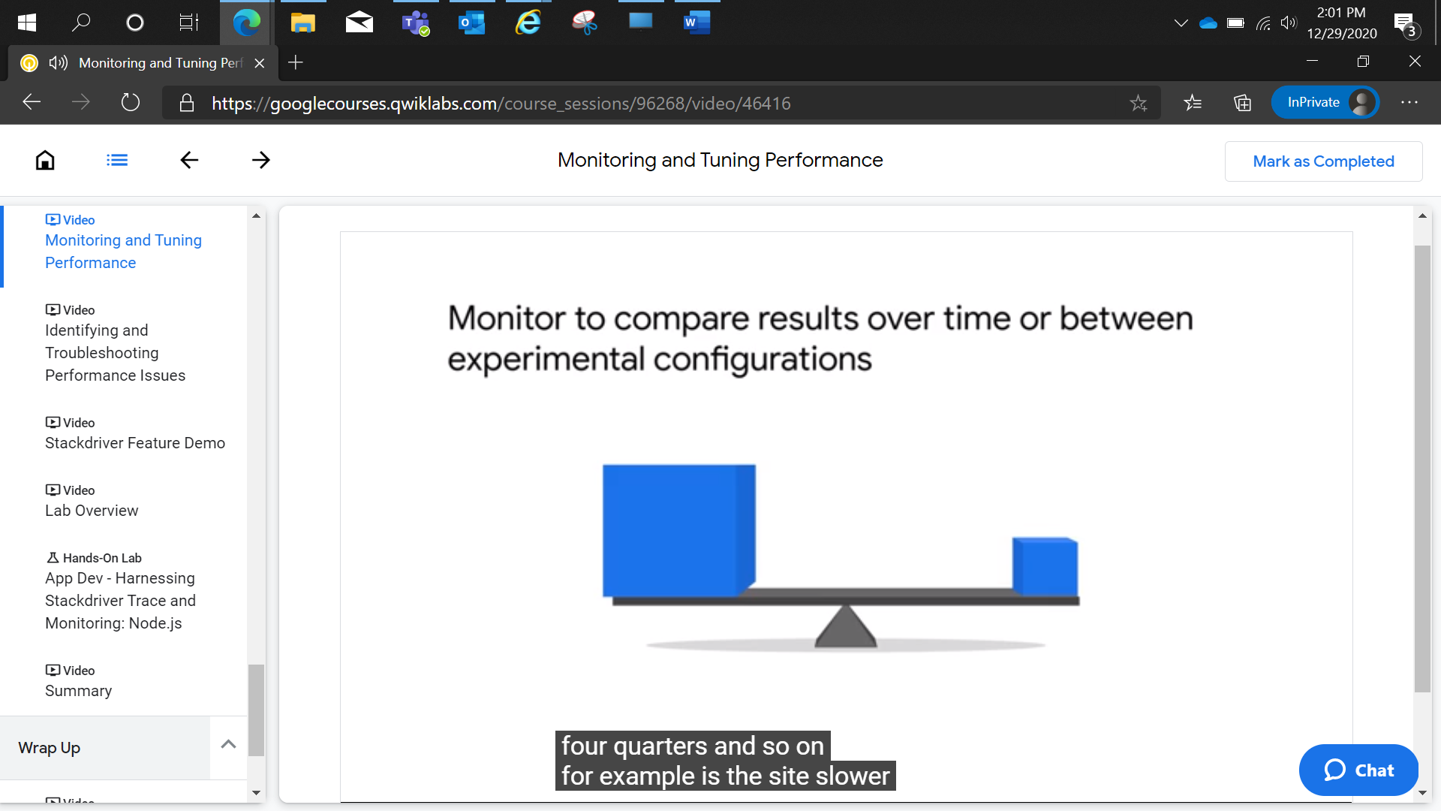

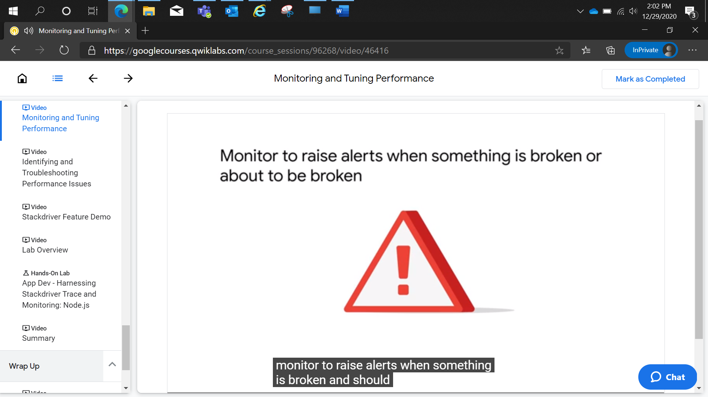

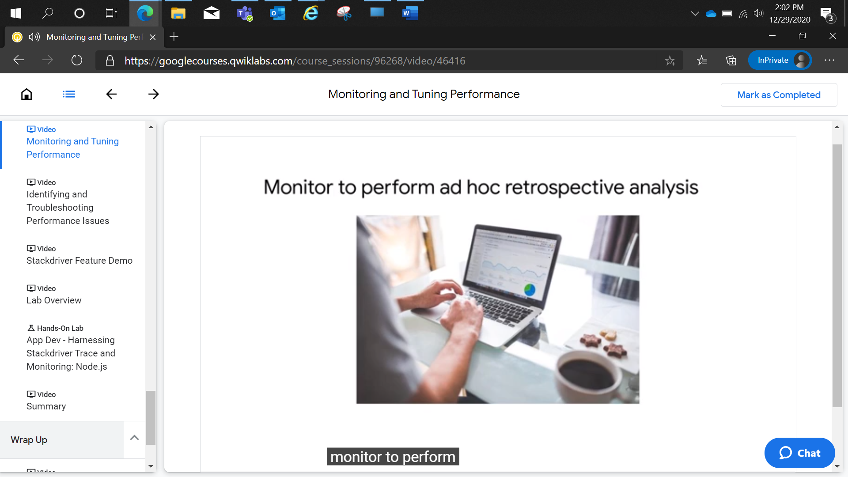

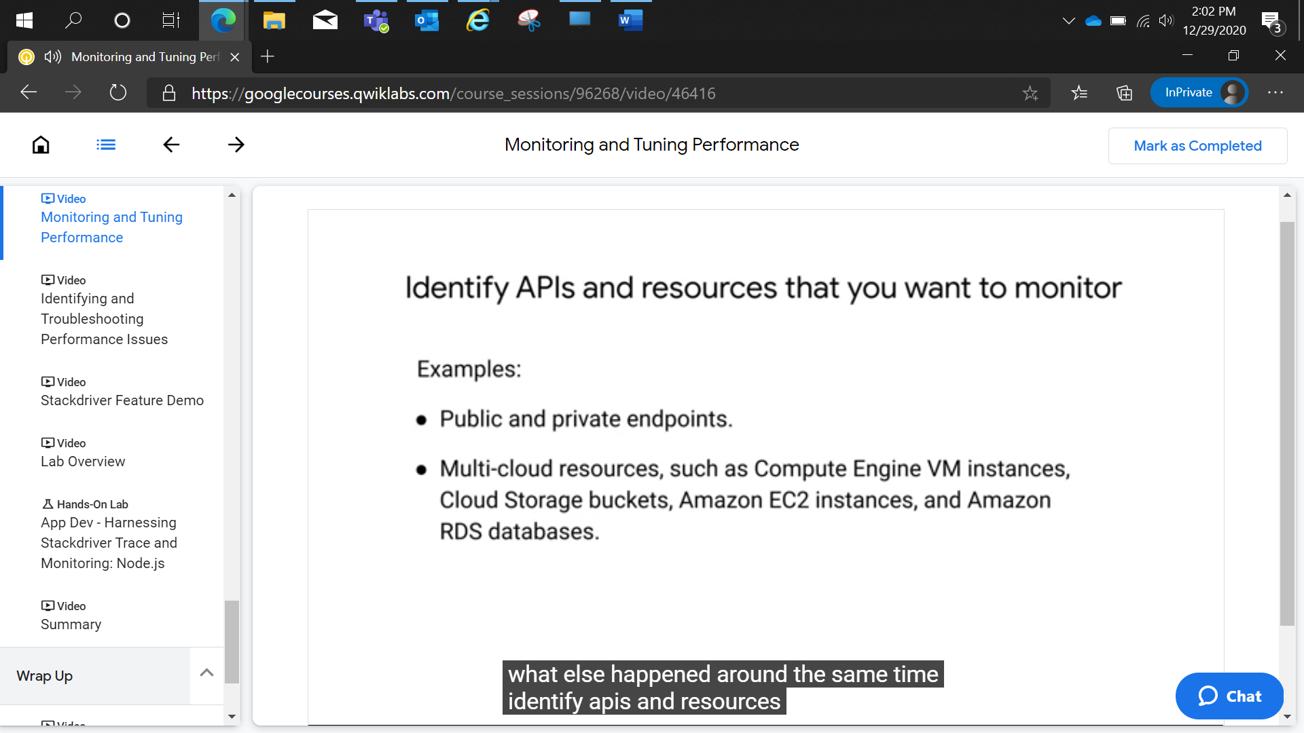

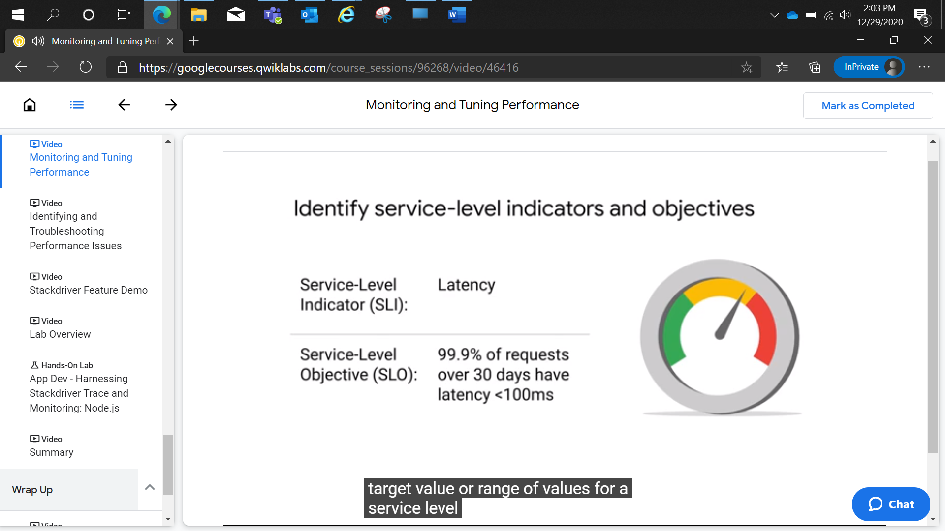

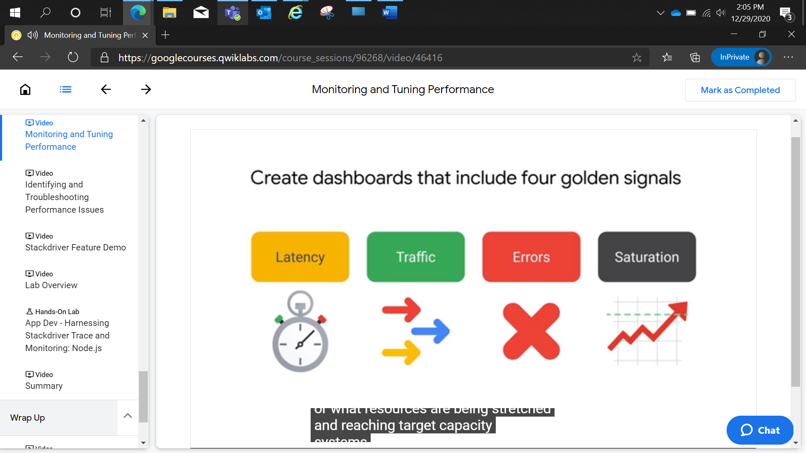

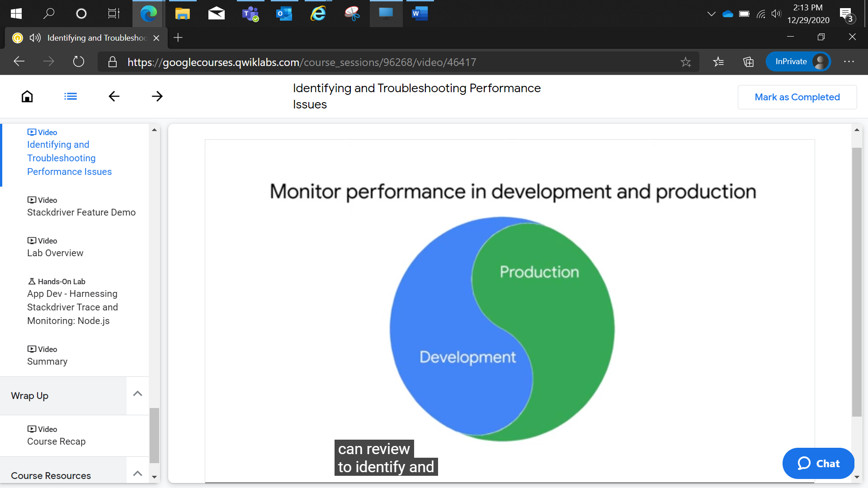

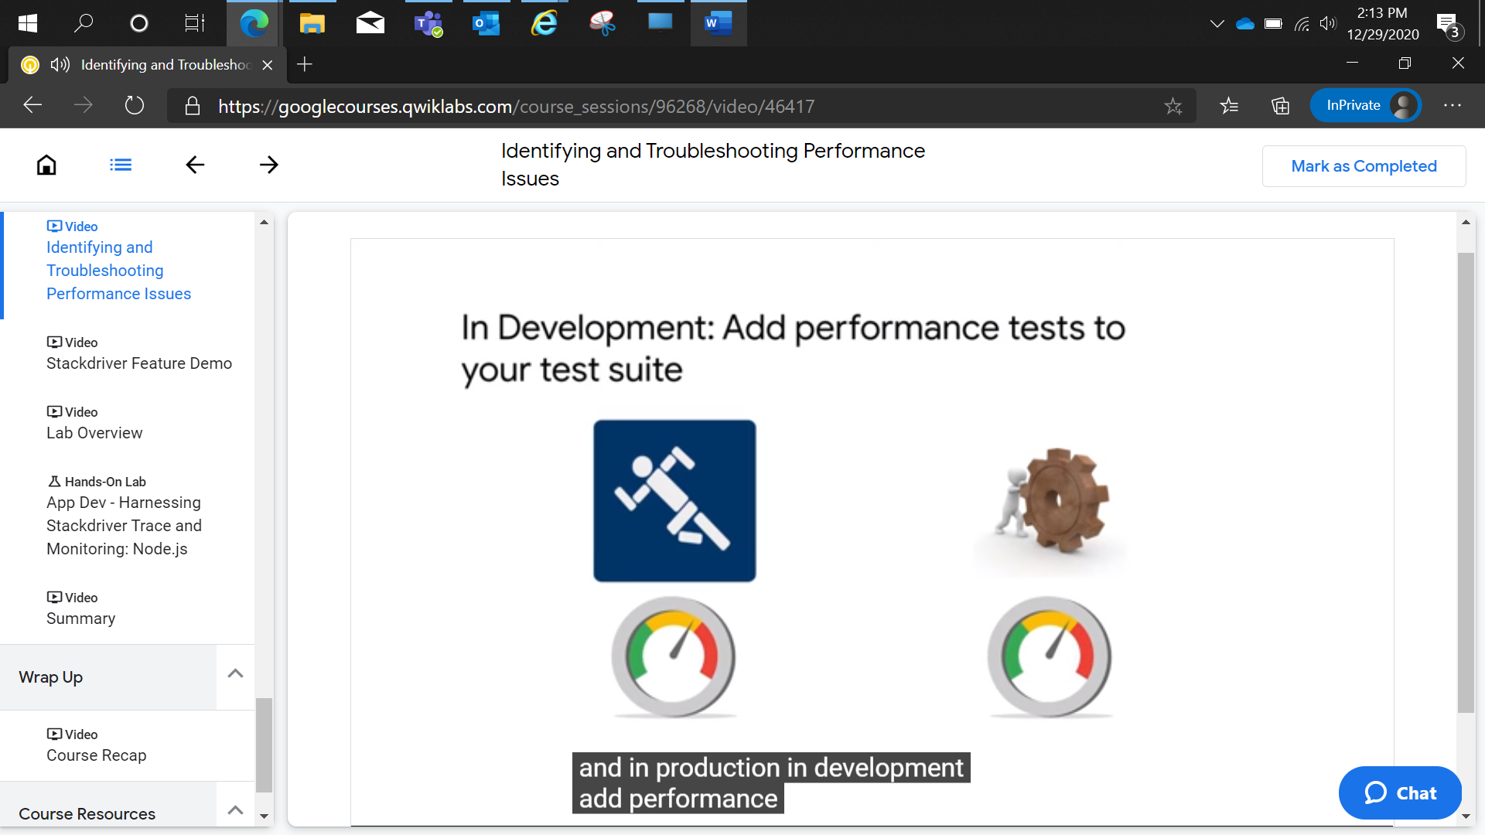

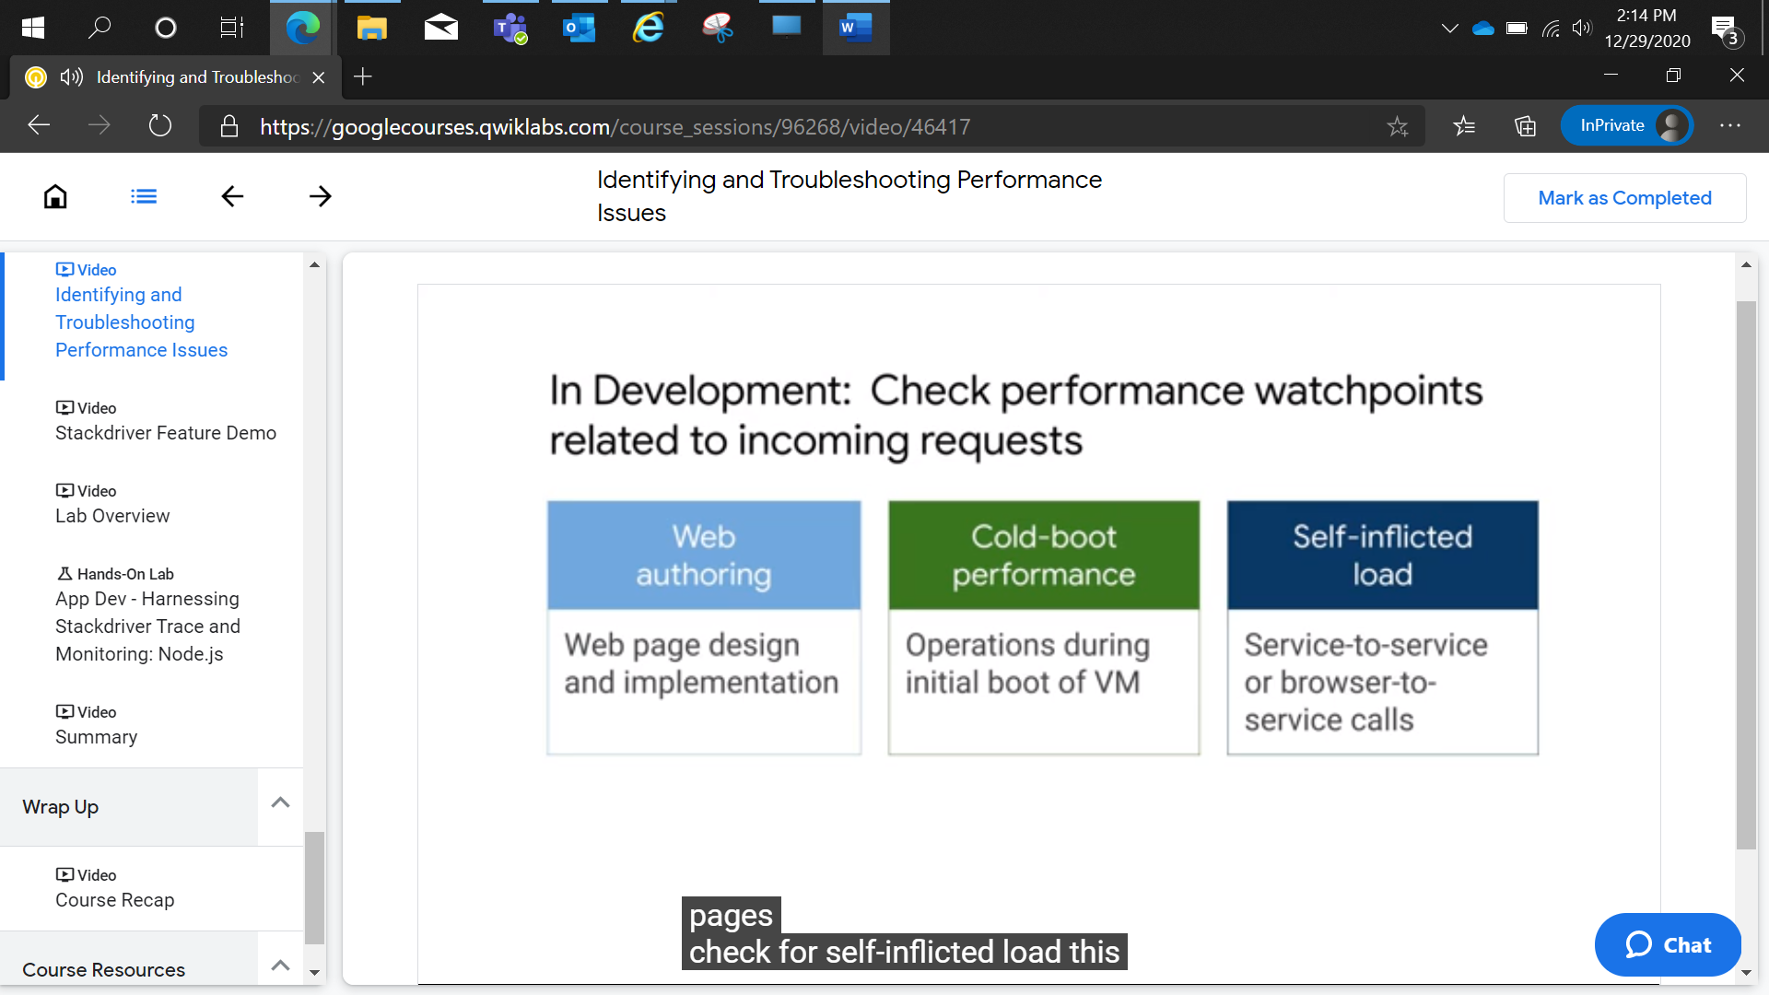

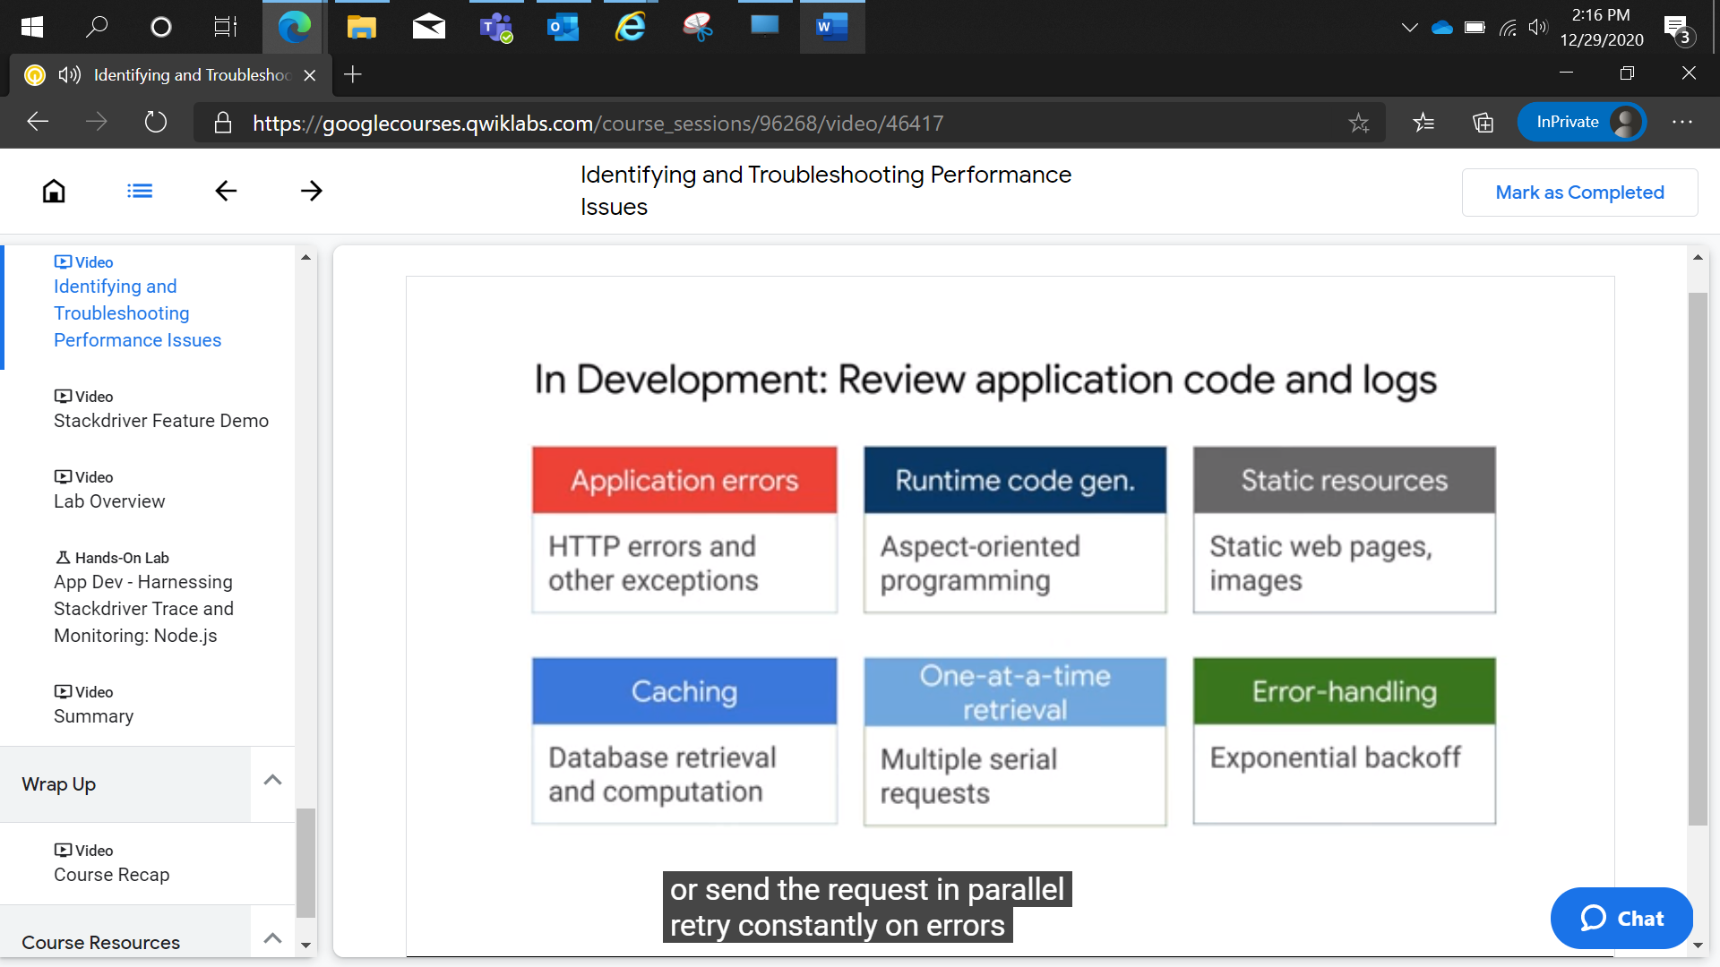

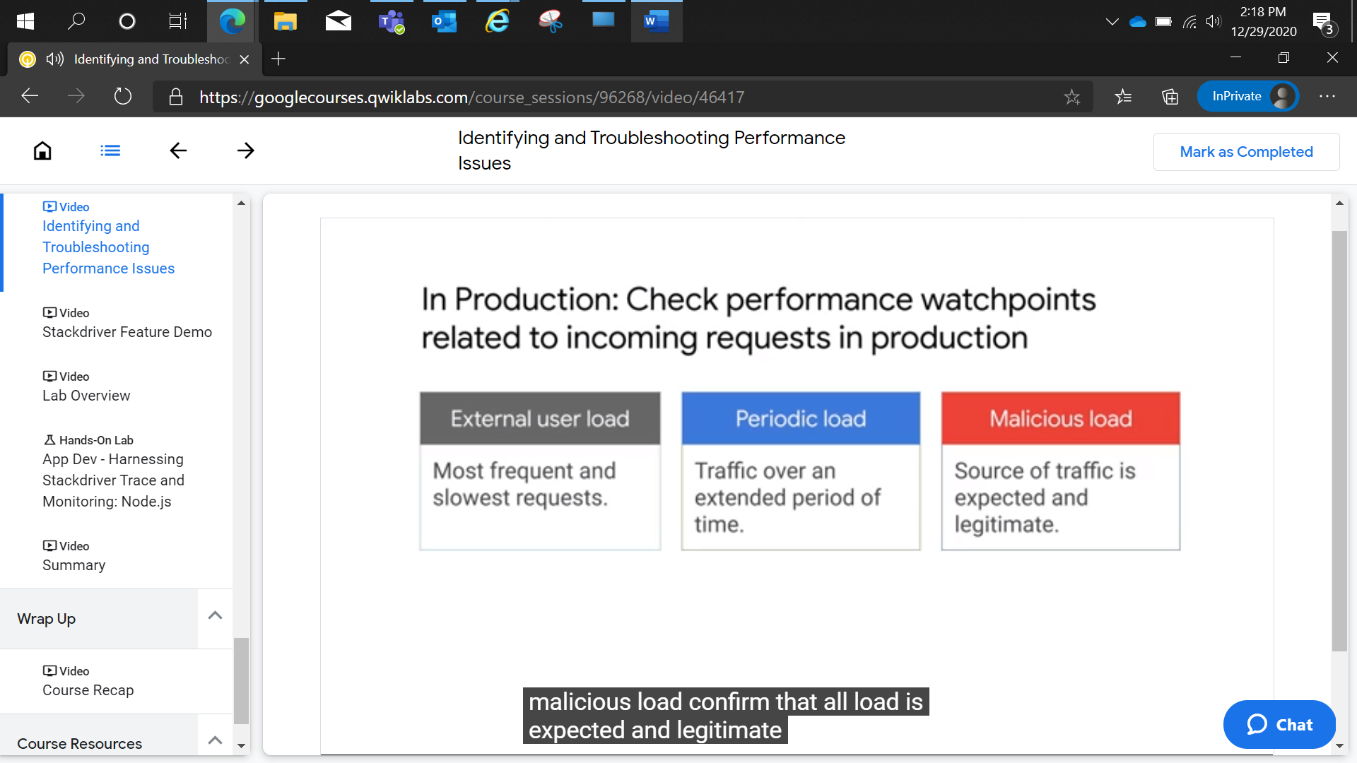

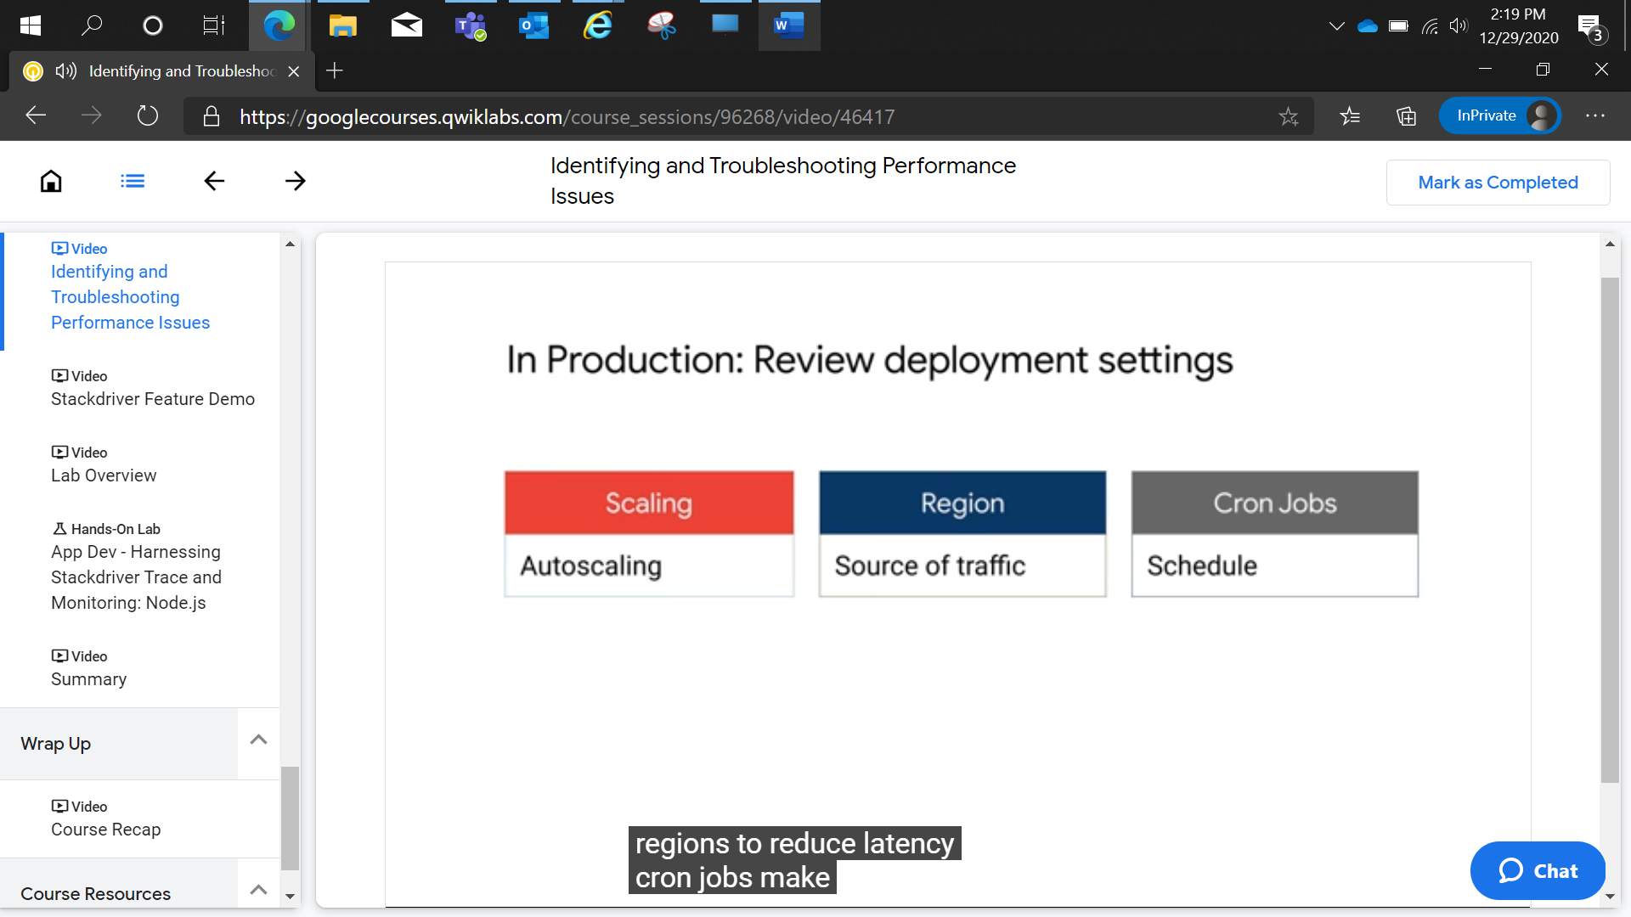

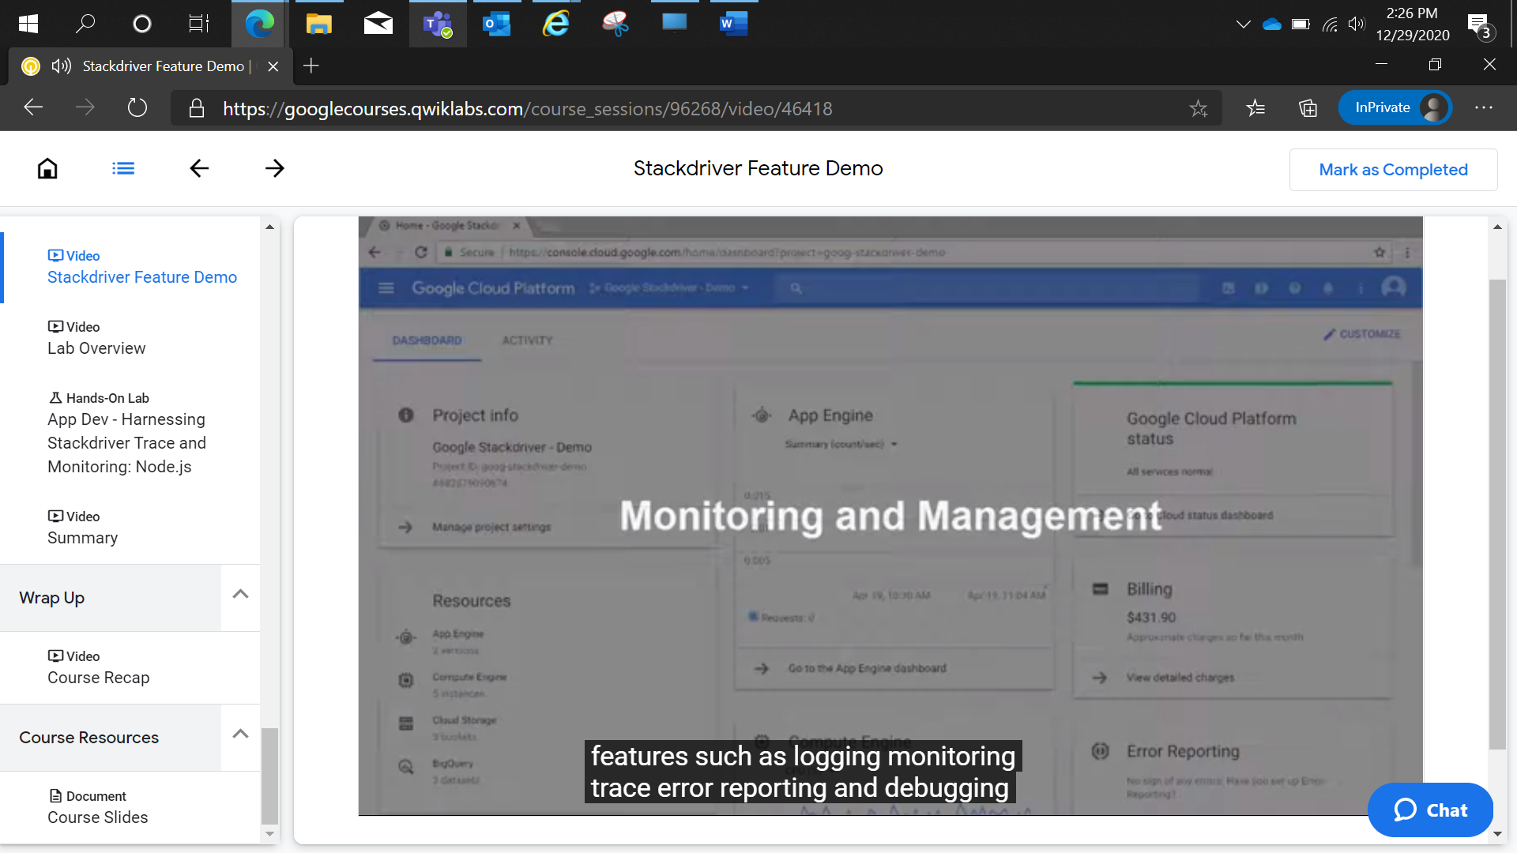

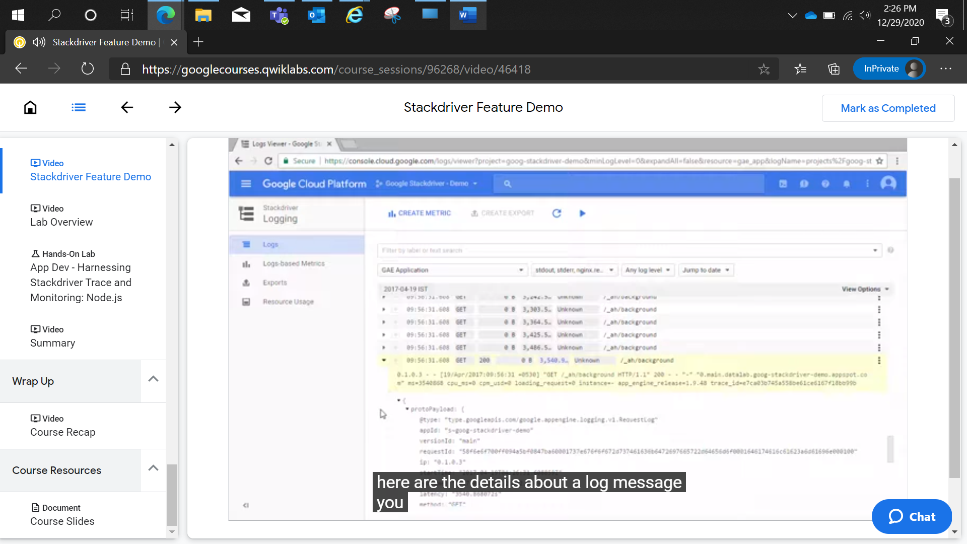

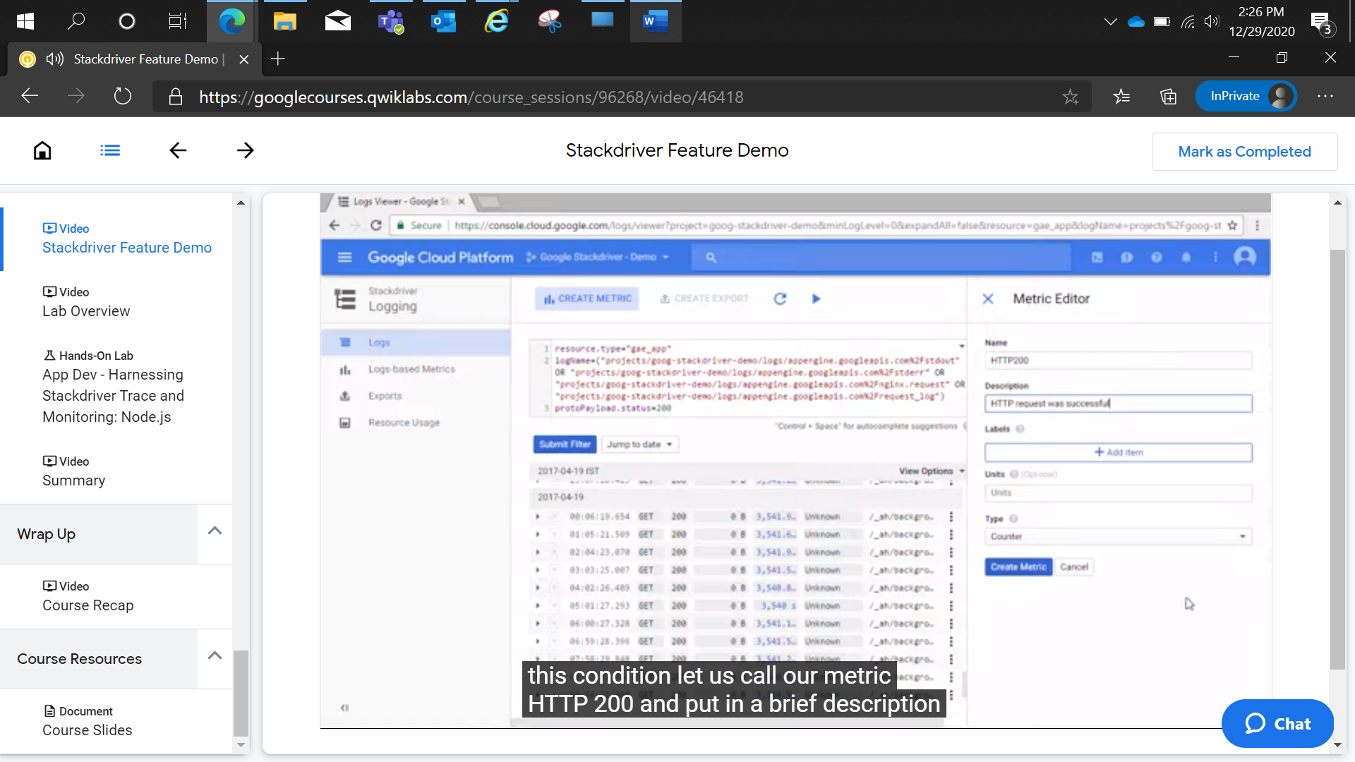

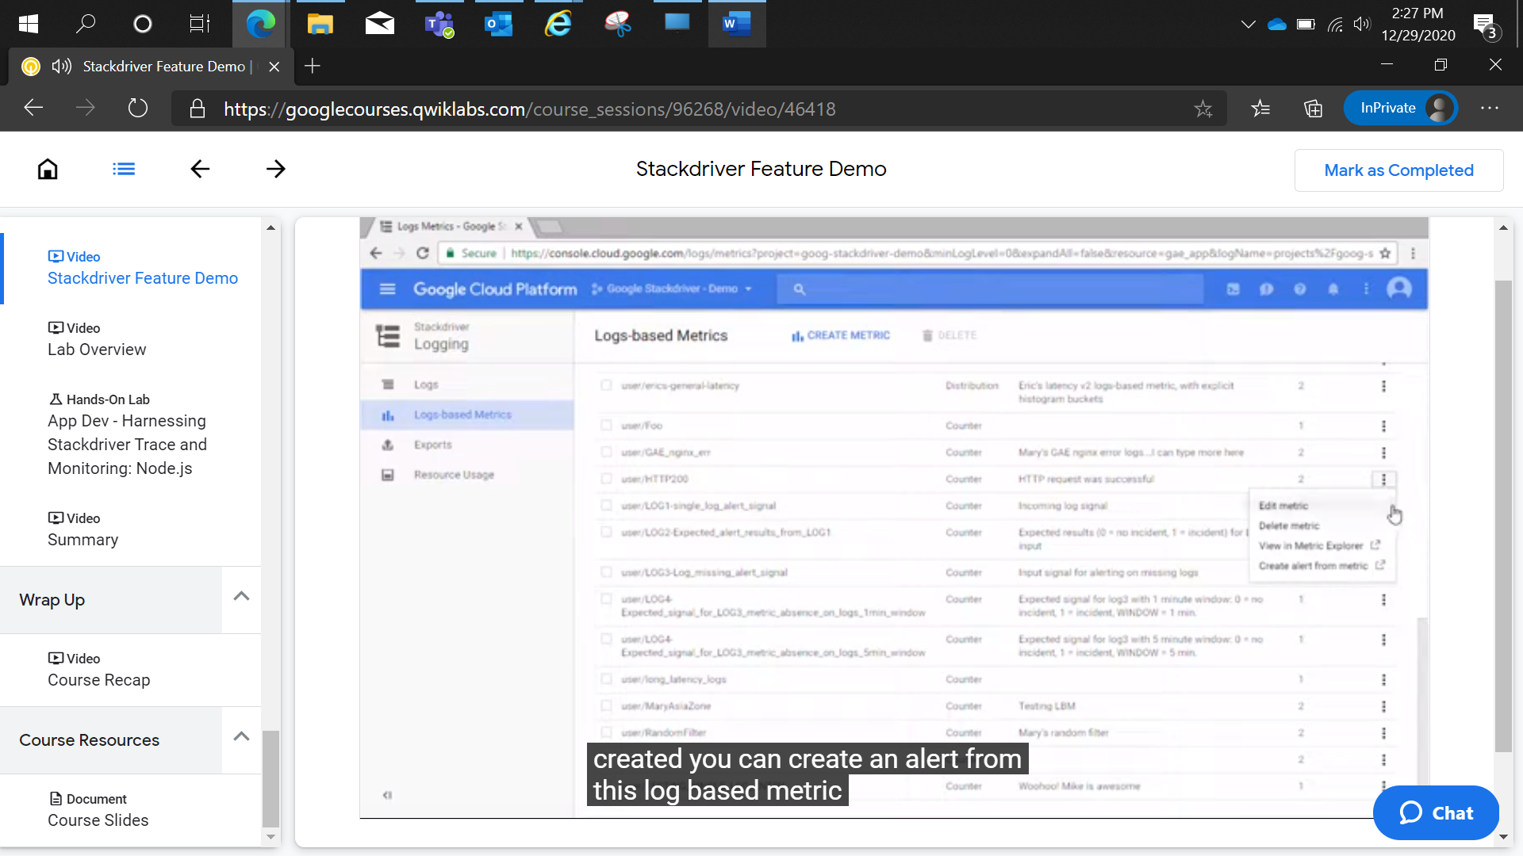

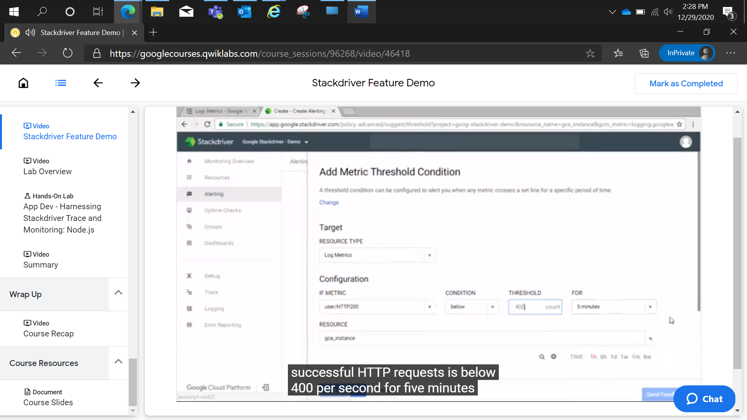

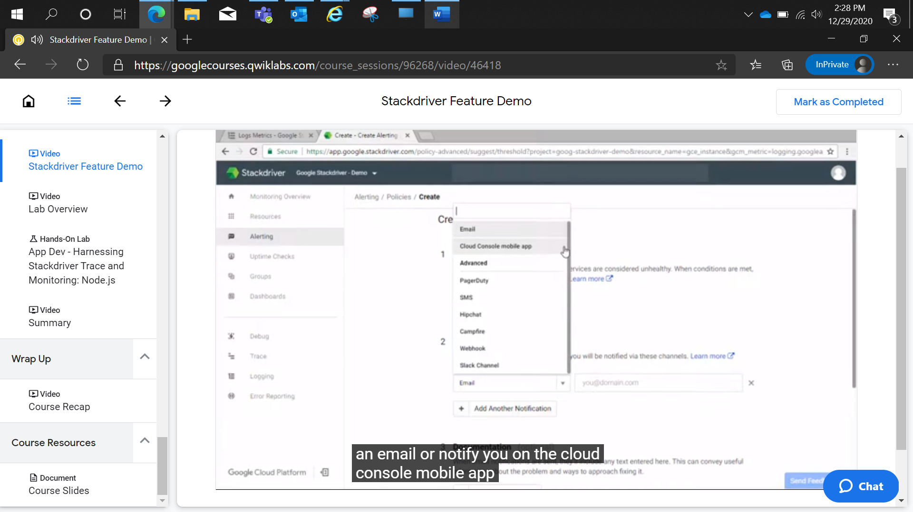

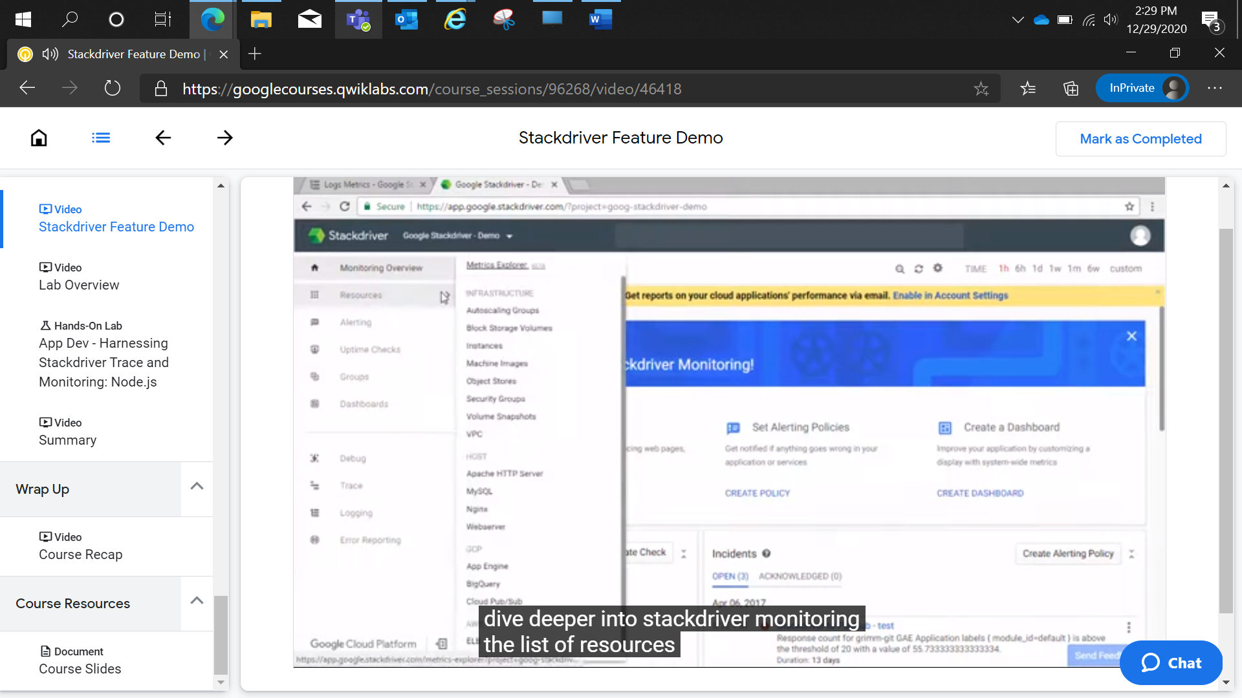

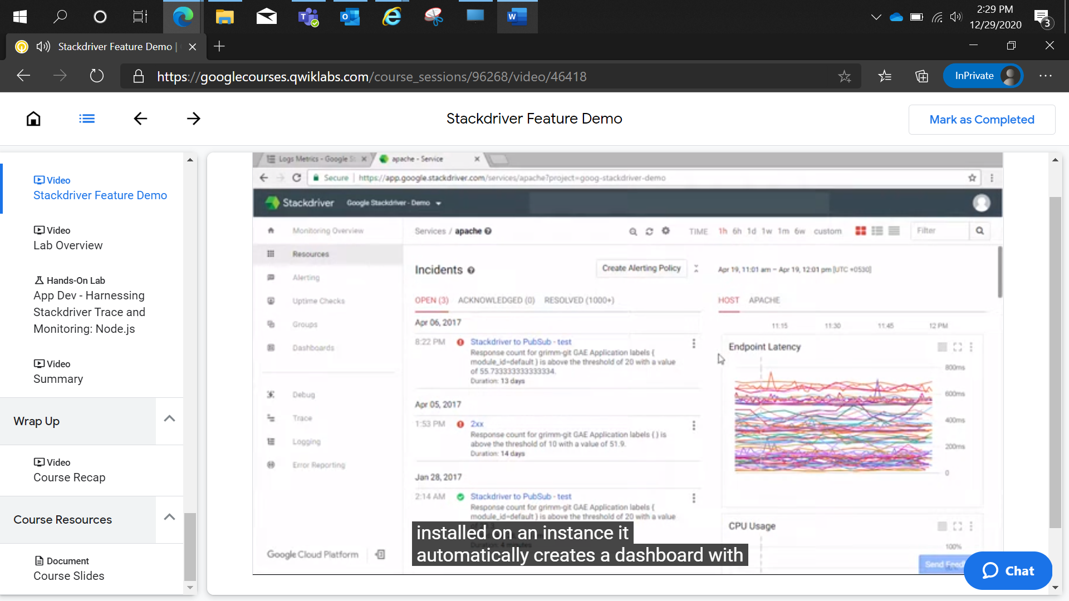

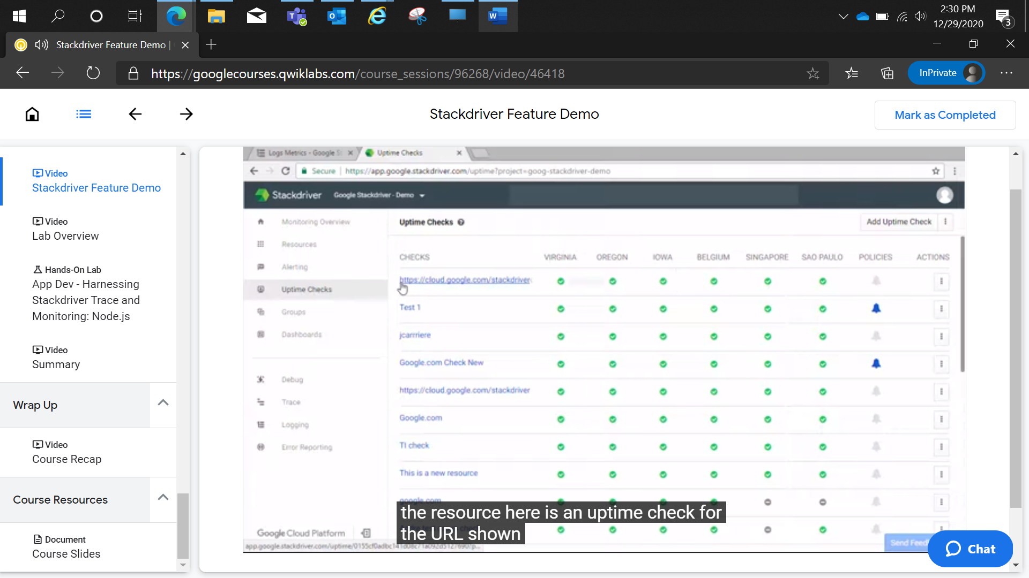

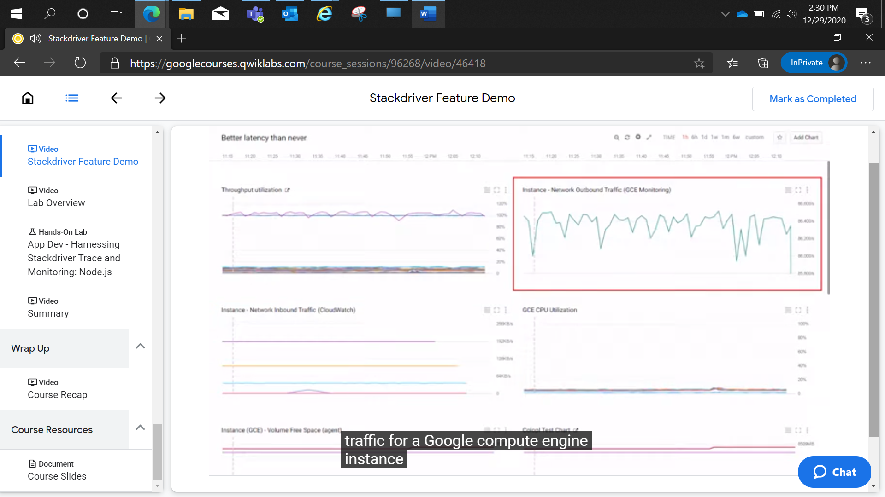

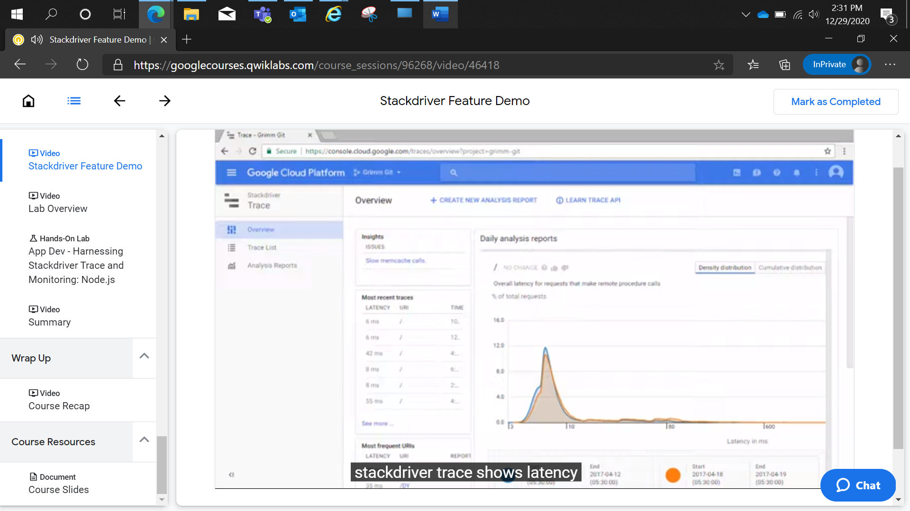

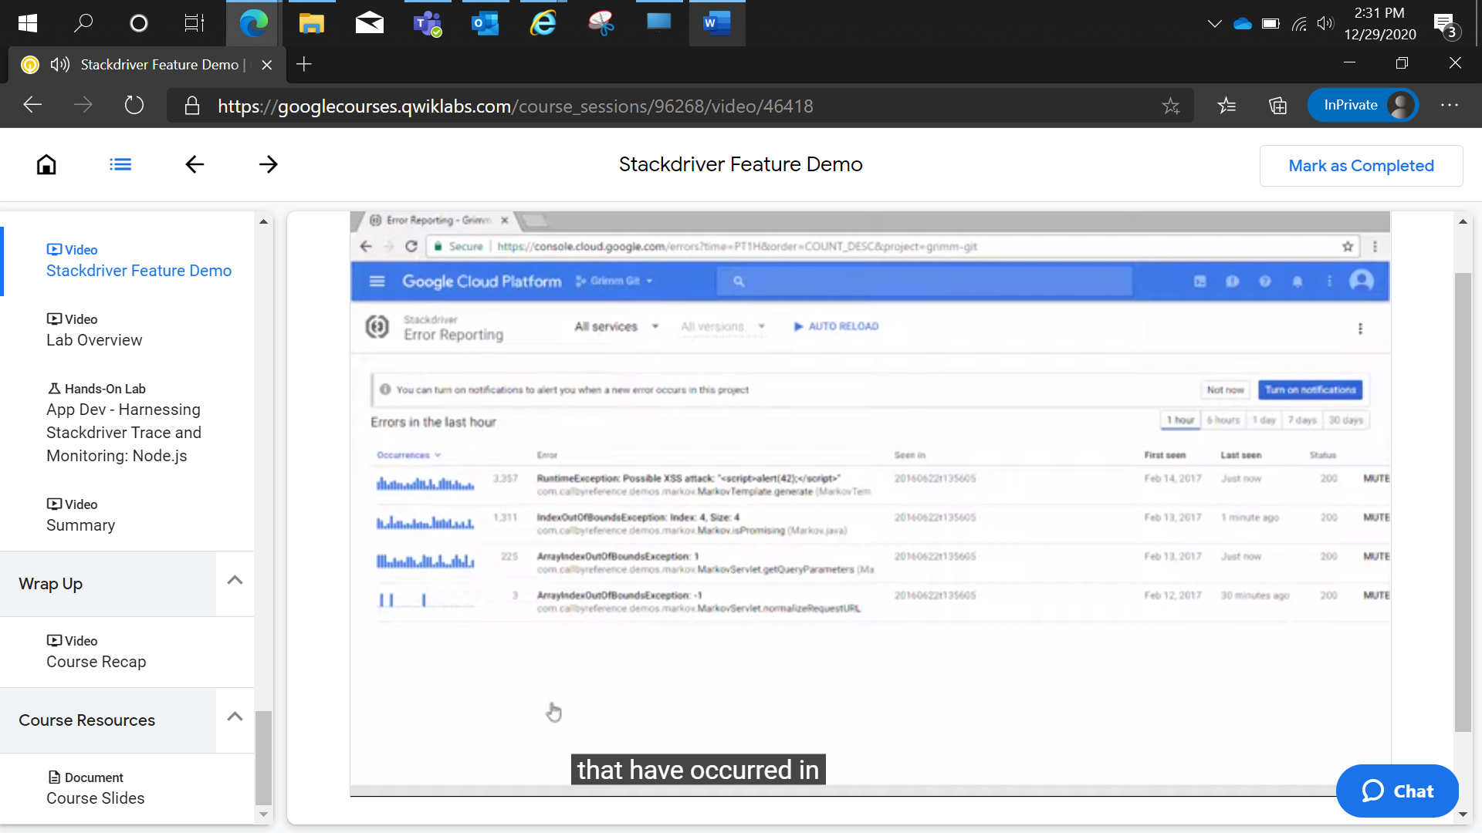

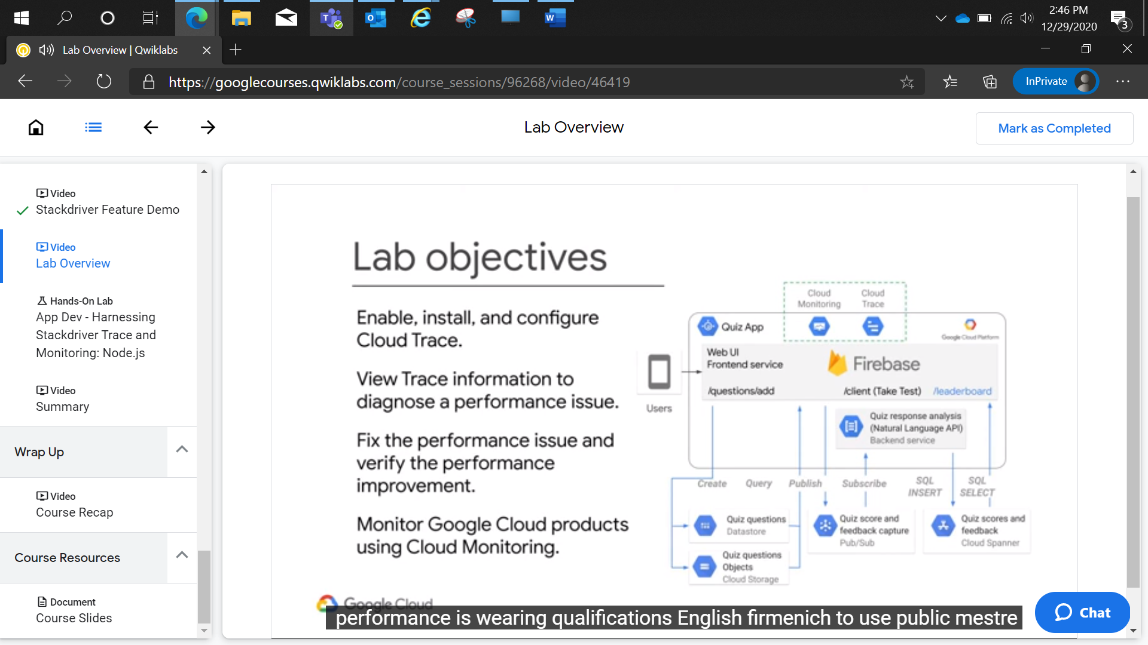

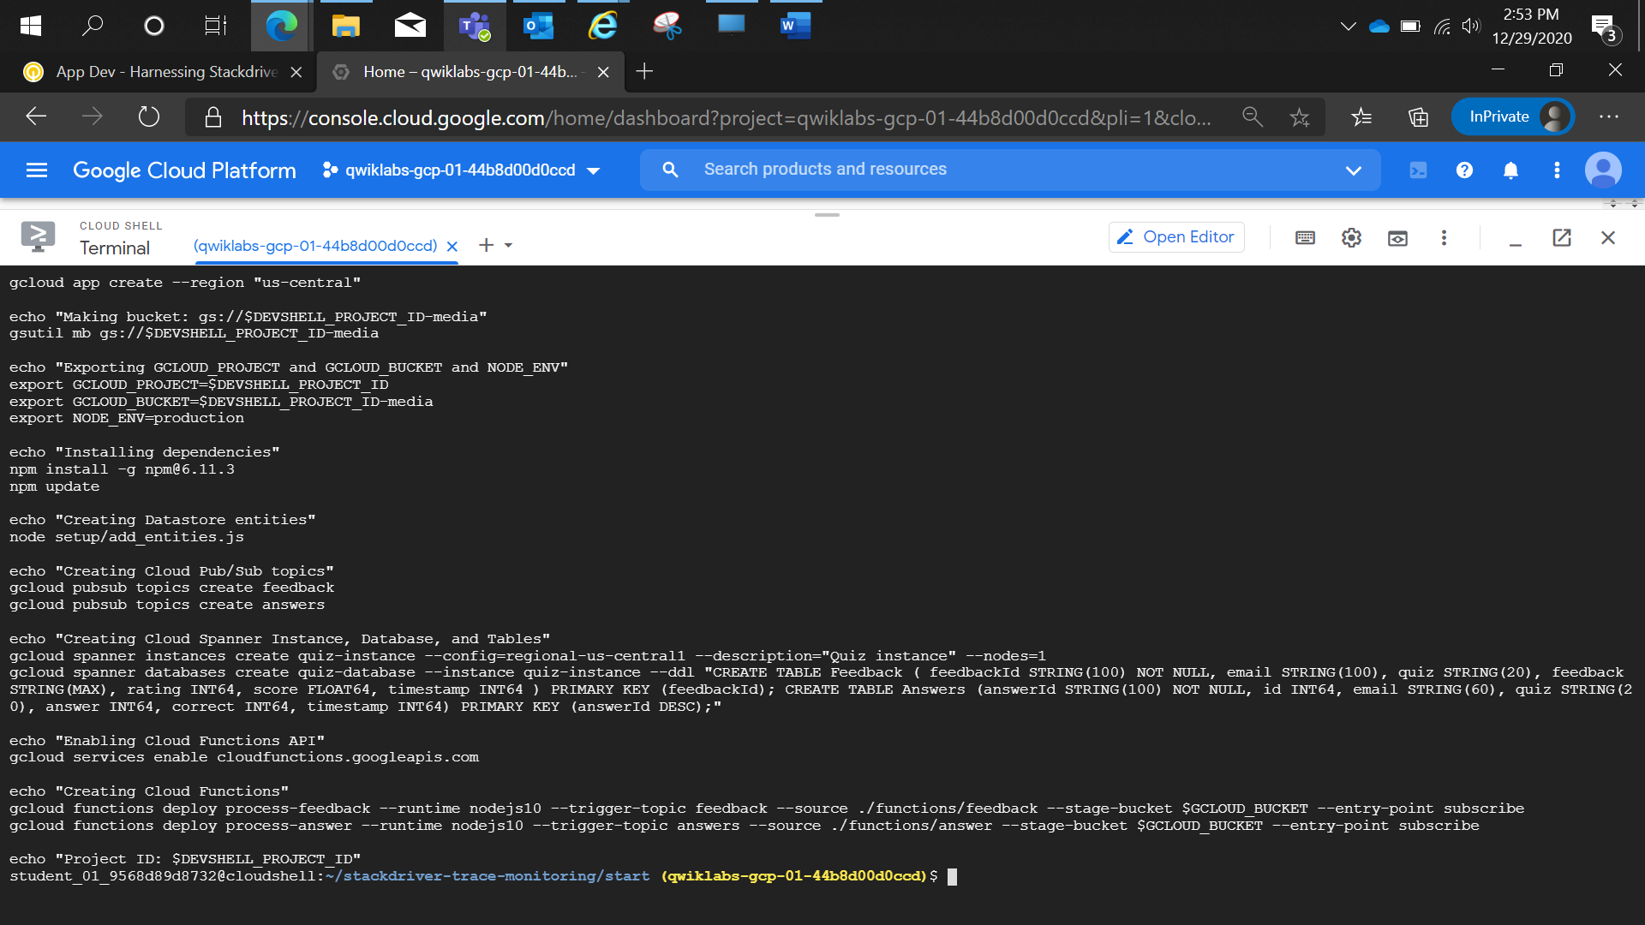

# **App Dev - Harnessing Stackdriver Trace and Monitoring: Node.js**

2 hoursFree

Rate Lab

## Overview

In this lab, you leverage Cloud Trace and Cloud Monitoring to diagnose and fix a performance issue in the running application and use Cloud Monitoring to view performance metrics of the application.

## Objectives

In this lab, you learn how to perform the following tasks:

* Enable, install, and configure Cloud Trace.
* View Trace information to diagnose a performance issue.
* Fix the performance issue and verify the performance improvement.
* Monitor Google Cloud Platform products using Cloud Monitoring.

## Setup and requirements

### **Lab setup**

For each lab, you get a new GCP project and set of resources for a fixed time at no cost.

1. Make sure you signed into Qwiklabs using an **incognito window**.
2. Note the lab's access time (for example,  and make sure you can finish in that time block.

There is no pause feature. You can restart if needed, but you have to start at the beginning.

1. When ready, click .
2. Note your lab credentials. You will use them to sign in to Cloud Platform Console. 
3. Click **Open Google Console**.
4. Click **Use another account** and copy/paste credentials for **this** lab into the prompts.

If you use other credentials, you'll get errors or **incur charges**.

1. Accept the terms and skip the recovery resource page.

Do not click **End Lab** unless you are finished with the lab or want to restart it. This clears your work and removes the project.

### **Activate Google Cloud Shell**

Google Cloud Shell is a virtual machine that is loaded with development tools. It offers a persistent 5GB home directory and runs on the Google Cloud. Google Cloud Shell provides command-line access to your GCP resources.

1. In GCP console, on the top right toolbar, click the Open Cloud Shell button.



1. Click **Continue**. 

It takes a few moments to provision and connect to the environment. When you are connected, you are already authenticated, and the project is set to your PROJECT_ID. For example:



**gcloud** is the command-line tool for Google Cloud Platform. It comes pre-installed on Cloud Shell and supports tab-completion.

You can list the active account name with this command:

gcloud auth list

content_copy

Output:

Credentialed accounts:

- <myaccount>@<mydomain>.com (active)content_copy

Example output:

Credentialed accounts:

- google1623327_student@qwiklabs.netcontent_copy

You can list the project ID with this command:

gcloud config list project

content_copy

Output:

[core]

project = <project_ID>content_copy

Example output:

[core]

project = qwiklabs-gcp-44776a13dea667a6content_copy

Full documentation of **gcloud** is available on [Google Cloud gcloud Overview](https://cloud.google.com/sdk/gcloud).

## Preparing the Case Study Application

In this section, you access Cloud Shell, clone the git repository containing the quiz application, configure environment variables. and run the application.

### **Clone source code in Cloud Shell**

1. To clone the repository for the class, execute the following command:

git clone https://github.com/GoogleCloudPlatform/training-data-analystcontent_copy

1. Create a soft link as a shortcut to the working directory:

ln -s ~/training-data-analyst/courses/developingapps/v1.2/nodejs/stackdriver-trace-monitoring ~/stackdriver-trace-monitoringcontent_copy

### **Configure and run the case study application**

1. Navigate to the directory that contains the sample files for this lab:

cd ~/stackdriver-trace-monitoring/startcontent_copy

1. To configure the Quiz application, execute the following command:

. prepare_environment.shcontent_copy

If prompted, enter Y to all unauthenticated invocations.

This script file

* Creates an App Engine application.
* Exports environment variables GCLOUD_PROJECT and GCLOUD_BUCKET.
* Runs npm install.
* Creates entities in Cloud Datastore.
* Creates a Cloud Spanner instance, database, and tables.
* Creates two Google Cloud Pub/Sub topics.
* Creates two Cloud Functions.
* Prints out the Google Cloud Platform Project ID.

1. To complete the preparation of the **Cloud Shell** environment to run the application, execute the following commands:

gcloud iam service-accounts create quiz-account --display-name "Quiz Account"

gcloud iam service-accounts keys create key.json --iam-account=quiz-account@$DEVSHELL_PROJECT_ID.iam.gserviceaccount.com

export GOOGLE_APPLICATION_CREDENTIALS=key.json

gcloud projects get-iam-policy $DEVSHELL_PROJECT_ID --format json > iam.json

node setup/add_iam_policy_to_service_account.js

gcloud projects set-iam-policy $DEVSHELL_PROJECT_ID iam_modified.jsoncontent_copy

These commands:

* Create a service account.
* Create and download the key file for the service account.
* Export an environment variable GOOGLE_APPLICATION_CREDENTIALS referencing the key file.
* Create the necessary IAM permissions to enable the service account to access all required APIs.

In production on Compute Engine or Container Engine, you would grant access to APIs either using a custom service account or via scopes. Typically, you would allow GCP to manage key rotation.

## Harnessing Cloud Trace

In this section, you enable the Trace API, write the code to create and start the Cloud Trace in the Quiz application, and view application timings across multiple products in the Cloud Platform Console.

### **Enable the Cloud Trace API**

1. In the **Cloud Platform Console**, on the **Navigation menu**, click **APIs & services**.
2. Click **Library**.
3. For **Search for APIs & services**, type **Google Trace**.
4. Click **Stackdriver Trace API**.
5. If the API is not enabled, click **Enable**.

### **Write code to set up Cloud Trace**

1. Return to **Cloud Shell**.
2. To install the Node.js agent for Cloud Trace, execute the following command:

npm install --save @google-cloud/trace-agentcontent_copy

1. In **Cloud Shell**, click **Open Editor** to open in a new window.
2. Navigate to **stackdriver-trace-monitoring/start**.
3. Open **...frontend/app.js**.

**Important**: Update code within the sections marked as follows:

// TODO

// END TODO

To maximize your learning, review the code, inline comments, and related API documentation.

1. At the top of the app.js file, load the '@google-cloud/trace-agent' module and then start() it.

#### frontend/app.js

*// TODO: Load the trace-agent and start it*

*// Trace must be started before any other code in the*

*// application.*

require('@google-cloud/trace-agent').start({

projectId: config.get('GCLOUD_PROJECT')

});

*// END TODO*content_copy

1. Save the file.

### **Run the web application and view trace data**

1. To start the application, execute the following command:

npm startcontent_copy

1. In **Cloud Shell**, click **Web preview** > **Preview on port 8080** to preview the quiz application.
2. Return to the **Cloud Platform Console**.
3. On the **Navigation menu**, click **Trace**.

The Trace overview page opens.

However, it may take a few minutes for the first request to populate.

After this happens, trace data is visible with just a few seconds' latency.

1. While waiting for the first Trace to populate, return to the **Cloud Shell** window and look for error messages.

Sometimes, due to a timing issue after enabling APIs, you might see errors about the Cloud Trace and/or Debug agent.

If you see errors, stop the Quiz application, restart after a minute, and then refresh the Quiz application home page.

1. Return to **Trace** in the **Cloud Platform Console**.
2. After your first Trace has populated, click **Trace List**.

You should see the Latency, HTTP Method, and URL for the request.

1. Return to the quiz application and click **Create Question**.
2. Fill in the form using the following values.

|  |  |
| --- | --- |
| **Form Field** | **Value** |
| Author | Your Name |
| Quiz | Google Cloud Platform |
| Title | Which Google Cloud product allows you to see request timing? |
| Answer 1 | Debugger |
| Answer 2 | Error Reporting |
| Answer 3 | Logging |
| Answer 4 | **Trace** (select the Answer 4 radio button) |

1. Click **Save**.
2. Return to the **Cloud Trace** window in the **Cloud Platform Console** and enable **Auto Reload**.

Look at the Trace list.

Eventually, two new requests are displayed:

1. GET /questions/add
2. POST /questions/add
3. Click on the POST request against the **/questions/add** URI.

You should see the total time to handle the request and the call made against the Cloud Datastore. The call to Cloud Datastore is shown in the trace list as an ip-address.

1. Return to the quiz application, and click **Take Test**.
2. Click **People**.
3. Complete the test, and submit feedback.
4. Return to the **Cloud Trace** window in the **Cloud Platform Console**.

Look at the Trace list again.

Eventually a set of new requests is displayed.

Find the following requests and click on them:

1. GET /api/quizzes/people
2. POST /api/quizzes/people
3. POST /api/quizzes/feedback/people

These represent the calls made from the client-side application against the quiz application.

Once again, you should see the total time taken to complete the request.

This time the POST requests should include IP addresses for Cloud Datastore and Cloud Pub/Sub.

Notice that the calls are sequential. This is because the Cloud Pub/Sub request needs the correct answers from Question entities in Cloud Datastore to send answer data to Cloud Pub/Sub for Storage in Cloud Spanner.

1. In the quiz application, click **Quite Interesting Quiz** in the toolbar, and then click **Leaderboard**.
2. Return to the **Cloud Trace** window in the **Cloud Platform Console** and review the Trace data for the new request.

You should see that this request includes calls to Cloud Spanner.

## Diagnosing a Performance Problem with Cloud Trace

In this section, you continue to explore the quiz application with Cloud Trace and identify and resolve a performance issue.

### **Identify a performance problem with Cloud Trace**

1. Return to the quiz application and click **Take Test**.
2. Click **Places**.
3. Complete the test, and submit feedback.
4. Return to the **Cloud Trace** window in the **Cloud Platform Console**.

Look at the Trace list again.

Eventually a set of new requests will be displayed.

Find the following requests and click on them:

1. GET /api/quizzes/places
2. POST /api/quizzes/places

These represent the calls made from the client-side application against the quiz application.

Once again, you should see the total time taken to complete the request.

Once again, you should see that the POST request includes IP addresses for Cloud Datastore and Cloud Pub/Sub.

Notice that the calls are sequential. This is because the Cloud Pub/Sub request needs data from Cloud Datastore to send the answer data to Cloud Pub/Sub.

However, you should also see that each call to Cloud Pub/Sub is also sequential; this is not OK!

1. Return to the quiz application and click **Take Test** again.
2. Click **GCP**.
3. Complete the test, and submit feedback.
4. Return to the **Cloud Trace** window in the **Cloud Platform Console**.

Look at the Trace list once again.

Eventually a set of new requests will be displayed.

Find the following requests and click on them:

1. GET /api/quizzes/gcp
2. POST /api/quizzes/gcp

These represent the calls made from the client-side application against the quiz application.

Once again, you should see the total time taken to complete the request.

Once again, you should see that the POST request includes IP addresses for Cloud Datastore and Cloud Pub/Sub.

Notice that the calls are sequential. This is because the Cloud Pub/Sub request needed data from Cloud Datastore to send the answer data to Cloud Pub/Sub.

However, you should also see that once again, each call to Cloud Pub/Sub is also sequential.

With four questions in the quiz, it's taking four times as long to send the Cloud Pub/Sub messages!

This is definitely not OK!

### **Modify application code to resolve the performance problem**

1. Return to the **Cloud Shell** and launch the **Code editor** if it is not opened already.
2. Navigate to **stackdriver-trace-monitoring/start/**.
3. Open ...frontend/api/index.js.
4. Find the statement that publishes answer messages in sequence, and modify it to perform the operations in parallel.

Fortunately, this is a very easy change to make! The code change is shown below:

#### api/index.js before the change

*// TODO: Sends the answers to Pub/Sub in parallel*

*// Sends the answers to Pub/Sub in sequence*

*// Change sequence to parallel in the next statement*

sequence(answersWithCorrect.map(answer => () => publisher.publishAnswer(answer))).then(() => {

*// Waits until all the Pub/Sub messages have been acknowledged before returning to the client*

const score = answersWithCorrect.filter(a => a.answer == a.correct).length;

res.status(200).json({ correct: score, total: questions.length });

});

*// END TODO*content_copy

#### api/index.js after the change

*// TODO: Sends the answers to Pub/Sub in parallel*

*// Changed to parallel*

parallel(answersWithCorrect.map(answer => () => publisher.publishAnswer(answer))).then(() => {

*// Waits until all the Pub/Sub messages have been acknowledged before returning to the client*

const score = answersWithCorrect.filter(a => a.answer == a.correct).length;

res.status(200).json({ correct: score, total: questions.length });

});

*// END TODO*content_copy

### **Confirm problem resolution with Cloud Trace**

1. Return to the **Cloud Shell**, stop the application by pressing **Ctrl+C**, and then start it again.
2. Return to the Quiz application, and take the **People**, **Places**, and **GCP** tests again.
3. Return to the **Cloud Trace** window in the **Cloud Platform Console**.

Look at the Trace list once again.

Eventually a set of new requests will be displayed.

Find the following requests and click on them:

1. GET /api/quizzes/people|places|gcp
2. POST /api/quizzes/people|places|gcp

These represent the calls made from the client-side application against the quiz application.

Once again, you should see the total time taken to complete the request.

This time, you should see that all of the Pub/Sub messages have been dispatched in parallel.

The time taken to complete processing of the requests is significantly lower.

## Visualizing Application Metrics with Cloud Monitoring

In this section, you continue to explore the quiz application with Cloud Monitoring by exploring metrics and create dashboards.

### **Create a Monitoring workspace**

You will now setup a Monitoring workspace that's tied to your Qwiklabs GCP Project. The following steps create a new account that has a free trial of Monitoring.

1. In the Google Cloud Platform Console, click on **Navigation menu** > **Monitoring**.
2. Wait for your workspace to be provisioned.

When the Monitoring dashboard opens, your workspace is ready.

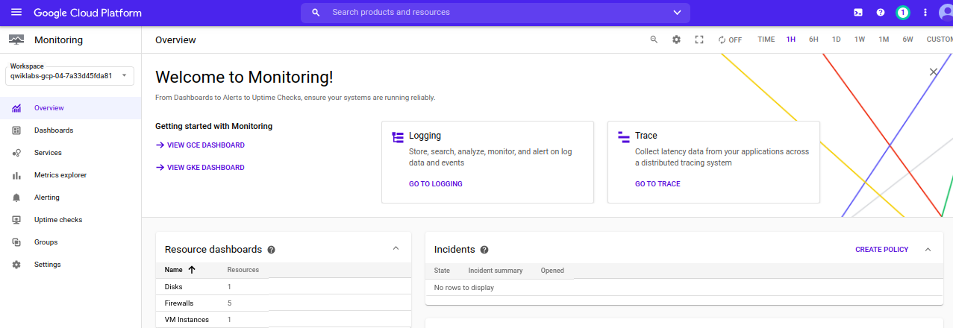

### **Explore Metrics**

1. In the left-hand pane, click **Metrics Explorer**.

Metrics Explorer allows you to navigate through all the resources that have been activated in your monitored projects.

1. Under **Find resource and metric**, click inside the **instance, cpu usage, etc.** textbox.

You should see that the following resources are active:

* cloud_function
* datastore_request
* gae_app (this is because of Cloud Datastore)
* gcs_bucket
* global
* pubsub_subscription
* pubsub_topic
* spanner_instance

1. Click on each resource in turn, and select a few metrics that are of interest to you.

Here are some example metrics to explore:

* cloudfunctions/function/execution_count
* datastore/api/request_count
* storage/api/request_count
* logging/log_entry_count
* pubsub/subscription/num_outstanding_messages
* pubsub/topic/message_sizes
* spanner/api/request_count

### **Create a Dashboard**

1. In the left-hand pane, click **Dashboards > Create Dashboard**.

Dashboards allow you to add multiple metrics into charts to display a set of monitoring data in a single location.

1. Click **Dashboard Editor** and select **Use Legacy Editor**.

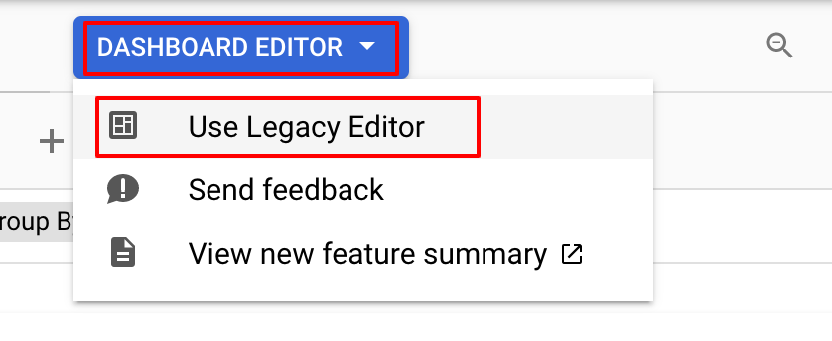

1. Click **Dismiss** for Switch to the dashboard editor to modify this dashboard.
2. Again, click **Dashboards** > **Create Dashboard**.
3. For **New Dashboard Name**, type **Quiz Application Metrics**, and press **Confirm**
4. Click **Add Chart**.

The charts include metrics similar to Metrics Explorer.

You can add multiple metrics to a single chart.

1. Click **Save**.
2. Create several charts, including your own selection of resource and metrics.

For guidance, think about the resources that are being used by the application, and build a chart that includes all of these resources.

1. Explore the functionality that lets you toggle the chart legend and themes.

You can switch to a dark theme, or include sophisticated statistics that show the maximum and minimum execution time, and much more!

**Review**

Which Google Cloud product should be loaded first, before any other code?

1. Cloud Trace
2. Cloud Debugger
3. Cloud Error Reporting
4. Cloud Logging

Which GCP products are integrated into Google Cloud Trace?

1. Cloud Datastore
2. Cloud Spanner
3. Cloud Pub/Sub
4. Cloud Storage

With Cloud Monitoring, which feature allows charts to be assembled to view performance of your application?

1. Alerting
2. Uptime Checks
3. Dashboards
4. Groups

